**QUESTION 1**

1. Which command is used to select partial table contents?

|  |  |  |
| --- | --- | --- |
|  |  | SELECT <column(s)> FROM <Table name> WHERE <Item>; |
|  |  | LIST <column(s)> FROM <Table name> WHERE <Conditions>; |
|  |  | ***SELECT <column(s)> FROM <Table name> WHERE <Conditions>;*** |
|  |  | LIST<column(s)> FROM <Table name> WHERE <Item>; |

**QUESTION 2**

1. Which query will output the table contents when the value of V_CODE is equal to 21344?

|  |  |  |
| --- | --- | --- |
|  |  | SELECT P_DESCRIPT, P_INDATE, P_PRICE, V_CODE FROM PRODUCT WHERE V_CODE <> 21344; |
|  |  | SELECT P_DESCRIPT, P_INDATE, P_PRICE, V_CODE FROM PRODUCT WHERE V_CODE <= 21344; |
|  |  | ***SELECT P_DESCRIPT, P_INDATE, P_PRICE, V_CODE FROM PRODUCT WHERE V_CODE = 21344;*** |
|  |  | SELECT P_DESCRIPT, P_INDATE, P_PRICE, V_CODE FROM PRODUCT WHERE V_CODE => 21344; |

**1 points**

**QUESTION 3**

1. Which query will output the table contents when the value of V_CODE is not equal to 21344?

|  |  |  |
| --- | --- | --- |
|  |  | **SELECT P_DESCRIPT, P_INDATE, P_PRICE, V_CODE FROM PRODUCT WHERE V_CODE <> 21344;** |
|  |  | SELECT P_DESCRIPT, P_INDATE, P_PRICE, V_CODE FROM PRODUCT WHERE V_CODE <= 21344; |
|  |  | SELECT P_DESCRIPT, P_INDATE, P_PRICE, V_CODE FROM PRODUCT WHERE V_CODE = 21344; |
|  |  | SELECT P_DESCRIPT, P_INDATE, P_PRICE, V_CODE FROM PRODUCT WHERE V_CODE => 21344; |

**1 points**

**QUESTION 4**

1. Which query will output the table contents when the value of V_CODE is less than or equal to 21344?

|  |  |  |
| --- | --- | --- |
|  |  | SELECT P_DESCRIPT, P_INDATE, P_PRICE, V_CODE FROM PRODUCT WHERE V_CODE <> 21344; |
|  |  | ***SELECT P_DESCRIPT, P_INDATE, P_PRICE, V_CODE FROM PRODUCT WHERE V_CODE <=21344;*** |
|  |  | SELECT P_DESCRIPT, P_INDATE, P_PRICE, V_CODE FROM PRODUCT WHERE V_CODE => 21344; |
|  |  | SELECT P_DESCRIPT, P_INDATE, P_PRICE, V_CODE FROM PRODUCT WHERE V_CODE = 21344; |

**QUESTION 5**

1. Which query will output the table contents when the value of the character field P_CODE is alphabetically less than 1558-QW1?

|  |  |  |
| --- | --- | --- |
|  |  | ***SELECT P_CODE, P_DESCRIPT, P_QOH, P_MIN, P_PRICE FROM PRODUCT WHERE P_CODE <'1558-QW1';*** |
|  |  | SELECT P_CODE, P_DESCRIPT, P_QOH, P_MIN, P_PRICE FROM PRODUCT WHERE P_CODE = [1558-QW1] |
|  |  | SELECT P_CODE, P_DESCRIPT, P_QOH, P_MIN, P_PRICE FROM PRODUCT WHERE P_CODE = (1558-QW1) |
|  |  | SELECT P_CODE, P_DESCRIPT, P_QOH, P_MIN, P_PRICEFROM PRODUCT WHERE P_CODE = {1558-QW1} |

**1 points**

**QUESTION 6**

1. Which SQL command will list all the rows in which the inventory stock dates occur on or after January 20, 2006?

|  |  |  |
| --- | --- | --- |
|  |  | ***?SELECT P_DESCRIPT, P_QOH, P_MIN, P_PRICE, P_INDATE FROM PRODUCT WHERE P_INDICATE >= '01/20/2006';*** |
|  |  | SELECT P_DESCRIPT, P_QOH, P_MIN, P_PRICE, P_INDATE FROM PRODUCT WHERE P_INDICATE >= #01/20/2004#; |
|  |  | SELECT P_DESCRIPT, P_QOH, P_MIN, P_PRICE, P_INDATE FROM PRODUCT WHERE P_INDICATE >= '20-JAN-2004'; |
|  |  | SELECT P_DESCRIPT, P_QOH, P_MIN, P_PRICE, P_INDATE FROM PRODUCT WHERE P_INDICATE >= {01-20-2004}; |

**1 points**

**QUESTION 7**

1. Which SQL command uses columns and column aliases to determine the total value of inventory held on hand?

|  |  |  |
| --- | --- | --- |
|  |  | SELECT P_DESCRIPT, P_QOH, P_PRICE, P_ONHAND/P_PRICE FROM PRODUCT; |
|  |  | SELECT P_DESCRIPT, P_QOH, P_PRICE, P_ONHAND=P_PRICE FROM PRODUCT; |
|  |  | ***SELECT P_DESCRIPT, P_QOH, P_PRICE, P_QOH*P_PRICE FROM PRODUCT;*** |
|  |  | SELECT P_DESCRIPT, P_QOH, P_PRICE, P_ONHAND-P_PRICE FROM PRODUCT; |

**1 points**

**QUESTION 8**

1. Which command uses columns and column aliases to determine the total value of inventory held on hand and to display the results in a column labeled TotValue?

|  |  |  |
| --- | --- | --- |
|  |  | ***SELECT P_DESCRIPT, P_QOH, P_PRICE, P_QOH*P_PRICE AS TOTVALUE FROM PRODUCT;*** |
|  |  | SELECT P_DESCRIPT, P_QOH, P_PRICE, P_QOH=P_PRICE AS TOTVALUE FROM PRODUCT; |
|  |  | SELECT P_DESCRIPT, P_QOH, P_PRICE, P_QOH/P_PRICE AS TOTVALUE FROM PRODUCT; |
|  |  | SELECT P_DESCRIPT, P_QOH, P_PRICE, P_QOH-P_PRICE AS TOTVALUE FROM PRODUCT; |

**1 points**

**QUESTION 9**

1. What is the SQL syntax requirement to list the table contents for either V_CODE = 21344 or V_CODE = 24288?

|  |  |  |
| --- | --- | --- |
|  |  | SELECT P_DESCRIPT, P_INDATE, P_PRICE, V_CODE FROM PRODUCT WHERE V_CODE = 21344 OR V_CODE <= 24288; |
|  |  | SELECT P_DESCRIPT, P_INDATE, P_PRICE, V_CODE FROM PRODUCT WHERE V_CODE = 21344 OR V_CODE => 24288; |
|  |  | SELECT P_DESCRIPT, P_INDATE, P_PRICE, V_CODE FROM PRODUCT WHERE V_CODE = 21344 OR V_CODE > 24288; |
|  |  | ***SELECT P_DESCRIPT, P_INDATE, P_PRICE, V_CODE FROM PRODUCT WHERE V_CODE = 21344 OR V_CODE = 24288;*** |

**QUESTION 10**

1. ANSI-standard SQL allows the use of a special operator in conjunction with the WHERE clause. The special operator used to define a range limit is ____.

|  |  |  |
| --- | --- | --- |
|  |  | ***BETWEEN*** |
|  |  | NULL |
|  |  | LIKE |
|  |  | IN |

**1 points**

**QUESTION 11**

1. ANSI-standard SQL allows the use of special operator in conjunction with WHERE clause. A special operator used to check whether an attribute has a value is ____.

|  |  |  |
| --- | --- | --- |
|  |  | BETWEEN |
|  |  | ***NULL*** |
|  |  | LIKE |
|  |  | IN |

**1 points**

**QUESTION 12**

1. What is the command used to list the P_CODE, P_DESCRIPT, P_INDATE, and P_PRICE fields from the Product table in ascending order by P_PRICE?

|  |  |  |
| --- | --- | --- |
|  |  | SELECT P_CODE, P_DESCRIPT, P_INDATE, P_PRICE FROM PRODUCT SEQUENCE BY P_PRICE; |
|  |  | SELECT P_CODE, P_DESCRIPT, P_INDATE, P_PRICE FROM PRODUCT LIST BY P_PRICE; |
|  |  | ***SELECT P_CODE, P_DESCRIPT, P_INDATE, P_PRICE FROM PRODUCT ORDER BY P_PRICE;*** |
|  |  | SELECT P_CODE, P_DESCRIPT, P_INDATE, P_PRICE FROM PRODUCT ASCENDING BY P_PRICE; |

**1 points**

**QUESTION 13**

1. What is the SQL command to output the contents of the Employee table?

|  |  |  |
| --- | --- | --- |
|  |  | SELECT EMP_LNAME, EMP_FNAME, EMP_INITIAL, EMP_AREACODE, EMP_PHONE FROM EMPLOYEE LIST BY EMP_LNAME, EMP_FNAME, EMP_INITIAL; |
|  |  | ***SELECT EMP_LNAME, EMP_FNAME, EMP_INITIAL, EMP_AREACODE, EMP_PHONE FROM EMPLOYEE ORDER BY EMP_LNAME, EMP_FNAME, EMP_INITIAL;*** |
|  |  | SELECT EMP_LNAME, EMP_FNAME, EMP_INITIAL, EMP_AREACODE, EMP_PHONE FROM EMPLOYEE DISPLAY BY EMP_LNAME, EMP_FNAME, EMP_INITIAL; |
|  |  | SELECT EMP_LNAME, EMP_FNAME, EMP_INITIAL, EMP_AREACODE, EMP_PHONE FROM EMPLOYEE SEQUENCE BY EMP_LNAME, EMP_FNAME, EMP_INITIAL; |

**1 points**

**QUESTION 14**

1. What command is used to list a unique value for V_CODE, where the list will produce only a list of those values that are different from one another?

|  |  |  |
| --- | --- | --- |
|  |  | SELECT ONLY V_CODE FROM PRODUCT; |
|  |  | SELECT UNIQUE V_CODE FROM PRODUCT; |
|  |  | SELECT DIFFERENT V_CODE FROM PRODUCT; |
|  |  | ***SELECT DISTINCT V_CODE FROM PRODUCT;*** |

**1 points**

**QUESTION 15**

1. The basic SQL aggregate function that gives the number of rows containing not null values for the given column is ____.

|  |  |  |
| --- | --- | --- |
|  |  | ***COUNT*** |
|  |  | NULL |
|  |  | MAX |
|  |  | SUM |

**1 points**

**QUESTION 16**

1. The basic SQL aggregate function that gives the total of all values for a selected attribute in a given column is ____.

|  |  |  |
| --- | --- | --- |
|  |  | TOTAL |
|  |  | SUBTOTAL |
|  |  | ADD |
|  |  | ***SUM*** |

**1 points**

**QUESTION 17**

1. What is the command to join the P_DESCRIPT and P_PRICE fields from the PRODUCT table and the V_NAME, V_AREACODE, V_PHONE, and V_CONTACT fields from the VENDOR table where the value of V_CODE match?

|  |  |  |
| --- | --- | --- |
|  |  | SELECT P_DESCRIPT, P_PRICE, V_NAME, V_CONTACT, V_AREACODE, V_PHONE FROM PRODUCT, VENDOR WHERE PRODUCT.V_CODE <> VENDOR.V_CODE; |
|  |  | ***SELECT P_DESCRIPT, P_PRICE, V_NAME, V_CONTACT, V_AREACODE, V_PHONE FROM PRODUCT, VENDOR WHERE PRODUCT.V_CODE = VENDOR.V_CODE;*** |
|  |  | SELECT P_DESCRIPT, P_PRICE, V_NAME, V_CONTACT, V_AREACODE, V_PHONE FROM PRODUCT, VENDOR WHERE PRODUCT.V_CODE <= VENDOR.V_CODE; |
|  |  | SELECT P_DESCRIPT, P_PRICE, V_NAME, V_CONTACT, V_AREACODE, V_PHONE FROM PRODUCT, VENDOR WHERE PRODUCT.V_CODE => VENDOR.V_CODE; |

**1 points**

**QUESTION 18**

1. What is the command to join the P_DESCRIPT and P_PRICE fields from the PRODUCT table and the V_NAME, V_AREACODE, V_PHONE and V_CONTACT fields from the VENDOR table, where the value of V_CODE match and the output is ordered by the Price?

|  |  |  |
| --- | --- | --- |
|  |  | SELECT P_DESCRIPT, P_PRICE, V_NAME, V_CONTACT, V_AREACODE, V_PHONE FROM PRODUCT, VENDOR WHERE PRODUCT.V_CODE <> VENDOR.V_CODE; ORDER BY P_PRICE; |
|  |  | SELECT P_DESCRIPT, P_PRICE, V_NAME, V_CONTACT, V_AREACODE, V_PHONE FROM PRODUCT, VENDOR WHERE PRODUCT.V_CODE => VENDOR.V_CODE; ORDER BY P_PRICE; |
|  |  | SELECT P_DESCRIPT, P_PRICE, V_NAME, V_CONTACT, V_AREACODE, V_PHONE FROM PRODUCT, VENDOR WHERE PRODUCT.V_CODE <= VENDOR.V_CODE; ORDER BY P_PRICE; |
|  |  | ***SELECT P_DESCRIPT, P_PRICE, V_NAME, V_CONTACT, V_AREACODE, V_PHONE FROM PRODUCT, VENDOR WHERE PRODUCT.V_CODE = VENDOR.V_CODE; ORDER BY P_PRICE;*** |

**1 points**

**QUESTION 19**

1. ANSI-standard SQL allows the use of special operators in conjunction with the WHERE clause. A special operator used to check whether an attribute value is null is ____. IN

|  |  |  |
| --- | --- | --- |
|  |  | BETWEEN |
|  |  | ***IS NULL*** |
|  |  | LIKE |
|  |  | IN |

**1 points**

**QUESTION 20**

1. ANSI-standard SQL allows the use of special operators in conjunction with the WHERE clause. A special operator used to check for similar character strings is ____.

|  |  |  |
| --- | --- | --- |
|  |  | BETWEEN |
|  |  | IS NULL |
|  |  | ***LIKE*** |
|  |  | IN |

**1 points**

**QUESTION 21**

1. ANSI-standard SQL allows the use of special operators in conjunction with the WHERE clause. A special operator used to check whether an attribute value matches a value contained within a subset of listed values is ____.

|  |  |  |
| --- | --- | --- |
|  |  | BETWEEN |
|  |  | IS NULL |
|  |  | LIKE |
|  |  | ***IN*** |

**1 points**

**QUESTION 22**

1. Concerning a user connection to Oracle, which of the following statements is false?

|  |  |  |
| --- | --- | --- |
|  |  | To connect to an Oracle database a user must provide a valid Oracle database name or connect string, e.g., SID=PACKY. |
|  |  | ?A table owner is always an Oracle user, but an Oracle user may not necessarily own any tables. |
|  |  | A table owner is the person who generally created the table. |
|  |  | **Tables in an Oracle database that do not have an owner are called shared or public tables.** |
|  |  | A user may execute SQL commands to process a table even though they don't own it. |

**1 points**

**QUESTION 23**

1. Given the following CREATE TABLE statements  
   CREATE TABLE PLAYER  
   (BATTER_FIRST_NAME VARCHAR2(10),  
   BATTER_LAST_NAME VARCHAR2(10),  
   TEAM VARCHAR2(10),  
   NUMBER_OF_HITS NUMBER(4),  
   NUMBER_AT_BATS NUMBER(4));  
   CREATE TABLE TEAM_INFO  
   (TEAM VARCHAR2(10),  
   TEAM_CITY VARCHAR2(10),  
   TEAM_OWNER VARCHAR2(10));  
     
   and the concept that a baseball batting average is equal to the number of hits divided by the number at bats, which of the following statements is syntactically correct?

|  |  |  |
| --- | --- | --- |
|  |  | SELECT BATTER_FIRST_NAME, BATTER_LAST_NAME, SUM(NUMBER_OF_HITS)   FROM PLAYER; |
|  |  | SELECT BATTER_FIRST_NAME, BATTER_LAST_NAME, SUM(NUMBER_OF_HITS)   FROM PLAYER GROUP BY TEAM; |
|  |  | **SELECT SUM(NUMBER_OF_HITS) FROM PLAYER GROUP BY TEAM;** |
|  |  | SELECT TEAM, SUM(NUMBER_OF_HITS) FROM PLAYER; |
|  |  | SELECT BATTER_FIRST_NAME, TEAM, SUM(NUMBER_OF_HITS)   FROM PLAYER GROUP BY TEAM; |

**1 points**

**QUESTION 24**

1. Given the following CREATE TABLE statements  
   CREATE TABLE PLAYER  
   (BATTER_FIRST_NAME VARCHAR2(10),  
   BATTER_LAST_NAME VARCHAR2(10),  
   TEAM VARCHAR2(10),  
   NUMBER_OF_HITS NUMBER(4),  
   NUMBER_AT_BATS NUMBER(4));  
   CREATE TABLE TEAM_INFO  
   (TEAM VARCHAR2(10),  
   TEAM_CITY VARCHAR2(10),  
   TEAM_OWNER VARCHAR2(10));  
     
   and the concept that a baseball batting average is equal to the number of hits divided by the number at bats, which of the following SQL statements will project an increase in the number of hits by 10% for each Pirate Players?

|  |  |  |
| --- | --- | --- |
|  |  | UPDATE PLAYER SET NUMBER_OF_HITS = NUMBER_OF_HITS * 1.10; |
|  |  | SELECT BATTER_FIRST_NAME, BATTER_LAST_NAME,  NUMBER_OF_HITS * 1.10 FROM PLAYER; |
|  |  | UPDATE PLAYER SET NUMBER_OF_HITS = NUMBER_OF_HITS * 1.10 WHERE TEAM = 'PIRATES'; |
|  |  | **SELECT BATTER_FIRST_NAME, BATTER_LAST_NAME,  NUMBER_OF_HITS * 1.10 FROM PLAYER WHERE TEAM = 'PIRATES';** |

**1 points**

**QUESTION 25**

1. Given the following CREATE TABLE statements  
   CREATE TABLE PLAYER  
   (BATTER_FIRST_NAME VARCHAR2(10),  
   BATTER_LAST_NAME VARCHAR2(10),  
   TEAM VARCHAR2(10),  
   NUMBER_OF_HITS NUMBER(4),  
   NUMBER_AT_BATS NUMBER(4));  
   CREATE TABLE TEAM_INFO  
   (TEAM VARCHAR2(10),  
   TEAM_CITY VARCHAR2(10),  
   TEAM_OWNER VARCHAR2(10));  
     
   and the concept that a baseball batting average is equal to the number of hits divided by the number at bats, which of the following SQL statements will increase the number of hits by 10% for each Pirate Players in the PLAYERS table?

|  |  |  |
| --- | --- | --- |
|  |  | UPDATE PLAYER SET NUMBER_OF_HITS = NUMBER_OF_HITS * 1.10; |
|  |  | SELECT BATTER_FIRST_NAME, BATTER_LAST_NAME, NUMBER_OF_HITS * 1.10 FROM PLAYER; |
|  |  | **UPDATE PLAYERSET NUMBER_OF_HITS = NUMBER_OF_HITS * 1.10 WHERE TEAM = 'PIRATES';** |
|  |  | SELECT BATTER_FIRST_NAME, BATTER_LAST_NAME,  NUMBER_OF_HITS * 1.10 FROM PLAYER WHERE TEAM = 'PIRATES'; |

**1 points**

**QUESTION 26**

1. Given the following CREATE TABLE statements  
   CREATE TABLE PLAYER  
   (BATTER_FIRST_NAME VARCHAR2(10),  
   BATTER_LAST_NAME VARCHAR2(10),  
   TEAM VARCHAR2(10),  
   NUMBER_OF_HITS NUMBER(4),  
   NUMBER_AT_BATS NUMBER(4));  
   CREATE TABLE TEAM_INFO  
   (TEAM VARCHAR2(10),  
   TEAM_CITY VARCHAR2(10),  
   TEAM_OWNER VARCHAR2(10));  
     
   and the concept that a baseball batting average is equal to the number of hits divided by the number at bats, which of the following statements is correctly display each team's batting average?

|  |  |  |
| --- | --- | --- |
|  |  | SELECT TEAM, SUM(NUMBER_OF_HITS)/SUM(NUMBER_AT_BATS) FROM PLAYER; |
|  |  | **SELECT TEAM, SUM(NUMBER_OF_HITS)/SUM(NUMBER_AT_BATS)   FROM PLAYER GROUP BY TEAM;** |
|  |  | SELECT SUM(NUMBER_OF_HITS), SUM(NUMBER_AT_BATS) FROM PLAYER GROUP BY TEAM; |
|  |  | SELECT SUM(NUMBER_OF_HITS), SUM(NUMBER_AT_BATS) FROM PLAYER; |
|  |  | SELECT TEAM, BATTING_AVERAGE   FROM PLAYER GROUP BY TEAM; |

**1 points**

**QUESTION 27**

1. Given the following CREATE TABLE statements  
   CREATE TABLE PLAYER  
   (BATTER_FIRST_NAME VARCHAR2(10),  
   BATTER_LAST_NAME VARCHAR2(10),  
   TEAM VARCHAR2(10),  
   NUMBER_OF_HITS NUMBER(4),  
   NUMBER_AT_BATS NUMBER(4));  
   CREATE TABLE TEAM_INFO  
   (TEAM VARCHAR2(10),  
   TEAM_CITY VARCHAR2(10),  
   TEAM_OWNER VARCHAR2(10));  
     
   and the concept that a baseball batting average is equal to the number of hits divided by the number at bats, which of the following statements will correctly display all players whose NUMBER_OF_HITS are greater than the Average Number of Hits?

|  |  |  |
| --- | --- | --- |
|  |  | SELECT BATTER_LAST_NAME, NUMBER_OF_HITS FROM PLAYER WHERE NUMBER_OF_HITS > AVG(NUMBER_OF_HITS); |
|  |  | **SELECT BATTER_LAST_NAME, NUMBER_OF_HITS FROM PLAYER WHERE NUMBER_OF_HITS > (SELECT AVG(NUMBER_OF_HITS) FROM PLAYER);** |
|  |  | SELECT BATTER_LAST_NAME, NUMBER_OF_HITS FROM PLAYER WHERE NUMBER_OF_HITS > AVG(NUMBER_OF_HITS) WHERE TEAM = 'Pirate'; |
|  |  | SELECT BATTER_LAST_NAME, NUMBER_OF_HITS FROM PLAYER HAVING NUMBER_OF_HITS > AVG(NUMBER_OF-HITS); |
|  |  | SELECT BATTER_LAST_NAME, NUMBER_OF_HITS FROM PLAYER WHERE NUMBER_OF_HITS > (SELECT AVG(NUMBER_OF_HITS) FROM PLAYER WHERE TEAM = 'Pirates'); |

**1 points**

**QUESTION 28**

1. Given the following SQL command  
     
   CREATE TABLE ABC AS  
   SELECT * FROM PLAYER  
   WHERE TEAM = 'Pirates';    
   Which of the following statements best describes the purpose of the above SQL statement?

|  |  |  |
| --- | --- | --- |
|  |  | A view named ABC is created that will only display Pirate players. |
|  |  | ***Information concerning Pirate Players is copied into a new table named ABC*** |
|  |  | A new table is created using the same column names and data types as used in the PLAYER table, but no data is copied. |
|  |  | This is an example of a UNION between the table named ABC and PLAYER |

**1 points**

**QUESTION 29**

1. Given the following statement  
     
   CREATE TABLE ABC AS  
   SELECT * FROM PLAYER  
   WHERE 1 = 2;    
   Which of the following statements best describes the purpose of the above SQL statement?

|  |  |  |
| --- | --- | --- |
|  |  | A view named ABC is created that will only display Pirate players. |
|  |  | Information concerning Pirate Players is copied into a new table named ABC |
|  |  | ***A new table is created using the same column names and data types as used in the PLAYER table, but no data is copied.*** |
|  |  | This is an example of a UNION between the table named ABC and PLAYER |

**1 points**

**QUESTION 30**

1. A form of a table join where one column of a table references its own primary key is called?

|  |  |  |
| --- | --- | --- |
|  |  | an intersection |
|  |  | **a self join** |
|  |  | an outer join |
|  |  | a Cartesian product |
|  |  | a simple join |

**1 points**

**QUESTION 31**

1. Consider the following SQL statement:  
   SELECT BATTER_FIRST_NAME, BATTER_LAST_NAME TEAM_INFO.TEAM, TEAM_CITY  
   FROM PLAYER, TEAM_INFO;  
   This is an example of:

|  |  |  |
| --- | --- | --- |
|  |  | an intersection |
|  |  | a self join |
|  |  | an outer join |
|  |  | ***a Cartesian product*** |
|  |  | a simple join |

**1 points**

**QUESTION 32**

1. Consider the following SQL statement:  
   SELECT BATTER_FIRST_NAME, BATTER_LAST_NAME TEAM_INFO.TEAM, TEAM_CITY  
   FROM PLAYER, TEAM_INFO  
   WHERE TEAM_INFO.TEAM = PLAYER.TEAM (+);  
   This is an example of:

|  |  |  |
| --- | --- | --- |
|  |  | an intersection |
|  |  | a self join |
|  |  | ?an outer join |
|  |  | ***a Cartesian product*** |
|  |  | a simple join |

**1 points**

**QUESTION 33**

1. Consider the following SQL statement:  
   SELECT BATTER_FIRST_NAME, BATTER_LAST_NAME TEAM_INFO.TEAM, TEAM_CITY  
   FROM PLAYER, TEAM_INFO  
   WHERE TEAM_INFO.TEAM = PLAYER.TEAM;  
   This is an example of:

|  |  |  |
| --- | --- | --- |
|  |  | an intersection |
|  |  | a self join |
|  |  | an outer join |
|  |  | a Cartesian product |
|  |  | **a simple join** |

**1 points**

**QUESTION 34**

1. Given the following statement  
     
   CREATE TABLE ABC AS  
   SELECT * FROM PLAYER  
   WHERE TEAM = 'Pirates';    
   Which of the following statements best describes the purpose of the above SQL statement?

|  |  |  |
| --- | --- | --- |
|  |  | A view named ABC is created that will only display Pirate players. |
|  |  | ***Information concerning Pirate Players is copied into a new table named ABC*** |
|  |  | A new table is created using the same column names and data types as used in the PLAYER table, but no data is copied. |
|  |  | This is an example of a UNION between the table named ABC and PLAYER |

**1 points**

**QUESTION 35**

1. Given the following statement  
     
   CREATE TABLE ABC AS  
   SELECT * FROM PLAYER  
   WHERE 1 = 2;    
   Which of the following statements best describes the purpose of the above SQL statement?

|  |  |  |
| --- | --- | --- |
|  |  | A view named ABC is created that will only display Pirate players. |
|  |  | Information concerning Pirate Players is copied into a new table named ABC |
|  |  | ***A new table is created using the same column names and data types as used in the PLAYER table, but no data is copied.*** |
|  |  | This is an example of a UNION between the table named ABC and PLAYER |

**1 points**

**QUESTION 36**

1. Concerning the application of referential integrity to Oracle, which of the following statements is false?

|  |  |  |
| --- | --- | --- |
|  |  | SQLPLUS has a facility to automatically commit your work without explicitiing telling it to do so, i.e., AutoCommit. |
|  |  | Rollback and commit will effect various events that effect the database; such as: Insert, Delete or update a row or column. |
|  |  | The default for Autocommit is set to Off |
|  |  | If you completed a serires of inserts, deletes, etc, but have not explicitly or implicitly committed them, Oracle will automatically rollback any uncommitted transactions. |
|  |  | ***If the autocommit facility has been turned off, one must commit each and every database transaction or change.*** |

**1 points**

**QUESTION 37**

1. An implicit Commit will force a commit to occur, even without your instructing it ot do so. Which of the following is not a event that will trigger an implicit commit?

|  |  |  |
| --- | --- | --- |
|  |  | Exiting or Quitting SqlPlus. |
|  |  | ***Executing almost any DDL statement, e.g., Create or Drop table, Create or Drop View.*** |
|  |  | ***Inserting multiple rows into the table.*** |
|  |  | Connecting or disconnecting to/from a database |
|  |  | Grating or revoking privlieges. |

**1 points**

**QUESTION 38**

1. The NOT IN operator has been criticized for poor performance. Whenever possible the NOT IN operator should be replaced by:

|  |  |  |
| --- | --- | --- |
|  |  | A Simple Join |
|  |  | An Outer Join |
|  |  | **A subquery** |
|  |  | Correlated Subquery |
|  |  | A Decode operator |

**1 points**

**QUESTION 39**

1. The IN operator can be replaced by:

|  |  |  |
| --- | --- | --- |
|  |  | A Simple Join |
|  |  | An Outer Join |
|  |  | ***A subquery*** |
|  |  | Correlated Subquery |
|  |  | A Decode operator |

**1 points**

**QUESTION 40**

1. The most frequent use of the EXIST operator is?

|  |  |  |
| --- | --- | --- |
|  |  | A Simple Join |
|  |  | An Outer Join |
|  |  | ***A subquery*** |
|  |  | Correlated Subquery |
|  |  | A Decode operator |

**1 points**

**QUESTION 41**

1. Performance of SQL WHERE statements that contain many AND operators that combined conditions from multiple tales can be improved by using

|  |  |  |
| --- | --- | --- |
|  |  | **A Union** |
|  |  | An Outer Join |
|  |  | The Or operator |
|  |  | **(wrong ans)Correlated Subquery** |
|  |  | An Intersection |

**1 points**

**QUESTION 42**

1. An advantage of using the EXIST operator as compared to the IN operator is that

|  |  |  |
| --- | --- | --- |
|  |  | ?multiple tables are joined |
|  |  | **it does not match a column or columns.** |
|  |  | does not require a primary key |
|  |  | uses the foreign key to improve performance. |

**1 points**

**QUESTION 43**

1. Which of the following is a relational set operator?

|  |  |  |
| --- | --- | --- |
|  |  | ***MINUS*** |
|  |  | PLUS |
|  |  | ?ALL |
|  |  | EXISTS |

**1 points**

**QUESTION 44**

1. What is meant by "union-compatible"?

|  |  |  |
| --- | --- | --- |
|  |  | The names of the relation attributes can be different, but the data types must be identical. |
|  |  | The names of the relation attributes must be the same, but the data types can be different. |
|  |  | **The names of the relation attributes must be the same and their data types must be identical.** |
|  |  | The number of attributes must be the same, but the names and data types can be different. |

**1 points**

**QUESTION 45**

1. Which data type is considered compatible with VARCHAR(35)?

|  |  |  |
| --- | --- | --- |
|  |  | DATE |
|  |  | INT |
|  |  | TINYINT |
|  |  | ***CHAR(15)*** |

**1 points**

**QUESTION 46**

1. Assume you are using the UNION operator to combine the results from two identical tables, CUSTOMER and CUSTOMER_2. The CUSTOMER table contains 10 rows, while the CUSTOMER_2 table contains 7 rows. Customers Dunne and Olowski are included in the CUSTOMER table as well as in the CUSTOMER_2 table. How many records are returned when using the UNION operator?

|  |  |  |
| --- | --- | --- |
|  |  | 7 |
|  |  | 10 |
|  |  | ***15*** |
|  |  | 17 |

**1 points**

**QUESTION 47**

1. Assume you are using the UNION ALL operator to combine the results from two identical tables, CUSTOMER and CUSTOMER_2. The CUSTOMER table contains 10 rows, while the CUSTOMER_2 table contains 7 rows. Customers Dunne and Olowski are included in the CUSTOMER table as well as in the CUSTOMER_2 table. How many records are returned when using the UNION ALL operator?

|  |  |  |
| --- | --- | --- |
|  |  | 7 |
|  |  | 10 |
|  |  | 15 |
|  |  | ***17*** |

**1 points**

**QUESTION 48**

1. Assume you are using the INTERSECT operator to combine the results from two identical tables, CUSTOMER and CUSTOMER_2. The CUSTOMER table contains 10 rows, while the CUSTOMER_2 table contains 7 rows. Customers Dunne and Olowski are included in the CUSTOMER table as well as in the CUSTOMER_2 table. How many records are returned when using the INTERSECT operator?

|  |  |  |
| --- | --- | --- |
|  |  | 0 |
|  |  | ***2*** |
|  |  | 7 |
|  |  | 10 |

**1 points**

**QUESTION 49**

1. Assume you are using the MINUS operator to combine the results from two identical tables, CUSTOMER and CUSTOMER_2. The CUSTOMER table contains 10 rows, while the CUSTOMER_2 table contains 7 rows. Customers Dunne and Olowski are included in the CUSTOMER table as well as in the CUSTOMER_2 table. How many records are returned when using the MINUS operator?

|  |  |  |
| --- | --- | --- |
|  |  | 0 |
|  |  | 2 |
|  |  | ***?7, 8*** |
|  |  | 10 |

**1 points**

**QUESTION 50**

1. The ____ statement in SQL combines rows from two queries and returns only the rows that appear in the first set but not in the second.

|  |  |  |
| --- | --- | --- |
|  |  | UNION |
|  |  | UNION ALL |
|  |  | ***INTERSECT*** |
|  |  | MINUS |

**1 points**

**QUESTION 51**

1. What operator could be used in place of INTERSECT if the RDBMS does not support it?

|  |  |  |
| --- | --- | --- |
|  |  | ***IN*** |
|  |  | OF |
|  |  | AND |
|  |  | UNION |

**1 points**

**QUESTION 52**

1. What operator could be used in place of MINUS if the RDBMS does not support it?

|  |  |  |
| --- | --- | --- |
|  |  | IN |
|  |  | ***NOT IN*** |
|  |  | AND |
|  |  | UNION |

**1 points**

**QUESTION 53**

1. The following SQL statement uses a(n) ____.  
   SELECT P_CODE, P_DESCRIPT, P_PRICE, V_NAME  
   FROM PRODUCT, VENDOR  
   WHERE PRODUCT.V_CODE = VENDOR.V_CODE;

|  |  |  |
| --- | --- | --- |
|  |  | set operator |
|  |  | natural join |
|  |  | ***"old-style" join*** |
|  |  | procedural statement |

**1 points**

**QUESTION 54**

1. When using a(n) ____ join, only rows that meet the given criteria are returned.

|  |  |  |
| --- | --- | --- |
|  |  | full |
|  |  | ***inner*** |
|  |  | outer |
|  |  | set |

**1 points**

**QUESTION 55**

1. The statement SELECT * FROM T1, T2 produces a(n) ____ join.

|  |  |  |
| --- | --- | --- |
|  |  | ***cross*** |
|  |  | natural |
|  |  | equi- |
|  |  | full |

**1 points**

**QUESTION 56**

1. A ____ join returns rows with matching values and includes all rows from both tables (T1 and T2) with unmatched values.

|  |  |  |
| --- | --- | --- |
|  |  | natural |
|  |  | cross |
|  |  | ***full outer*** |
|  |  | left outer |

**1 points**

**QUESTION 57**

1. How many different types of outer join are there?

|  |  |  |
| --- | --- | --- |
|  |  | 1 |
|  |  | 2 |
|  |  | ***3*** |
|  |  | 4 |

**1 points**

**QUESTION 58**

1. How many rows would be returned from a cross join of tables A and B, if A contains 10 rows and B contains 20?

|  |  |  |
| --- | --- | --- |
|  |  | 10 |
|  |  | 20 |
|  |  | 30 |
|  |  | ***200*** |

**1 points**

**QUESTION 59**

1. In a subquery, which query is executed first?

|  |  |  |
| --- | --- | --- |
|  |  | Leftmost |
|  |  | Rightmost |
|  |  | ***Innermost*** |
|  |  | Outermost |

**1 points**

**QUESTION 60**

1. The most common type of subquery uses an inner SELECT subquery on the right side of a(n) ____ comparison expression.

|  |  |  |
| --- | --- | --- |
|  |  | ***WHERE*** |
|  |  | JOIN |
|  |  | UNION |
|  |  | EXISTS |

**1 points**

**QUESTION 61**

1. When using an equality (=) or inequality (<, >, etc.) operator for a subquery, what type of value must the subquery return?

|  |  |  |
| --- | --- | --- |
|  |  | ***single value*** |
|  |  | list of values |
|  |  | no value |
|  |  | virtual table |

**1 points**

**QUESTION 62**

1. In order to compare one value to a list of values returned by a subquery, you must use a(n) ____ operand.

|  |  |  |
| --- | --- | --- |
|  |  | = |
|  |  | MINUS |
|  |  | ON |
|  |  | ***IN*** |

**1 points**

**QUESTION 63**

1. In addition to a WHERE clause, a subquery can be used with a(n) ____ clause.

|  |  |  |
| --- | --- | --- |
|  |  | ON |
|  |  | ***HAVING*** |
|  |  | GROUP BY |
|  |  | MINUS |

**1 points**

**QUESTION 64**

1. Which operator(s) are used with subqueries that use inequality operators on a list of values?

|  |  |  |
| --- | --- | --- |
|  |  | ANY |
|  |  | ***ANY and ALL*** |
|  |  | ON |
|  |  | ONLY |

**1 points**

**QUESTION 65**

1. The attribute list can also include a subquery expression, also known as a(n) ____ subquery.

|  |  |  |
| --- | --- | --- |
|  |  | having |
|  |  | correlated |
|  |  | ***inline*** |
|  |  | nested |

**1 points**

**QUESTION 66**

1. A subquery that executes once for each row in the outer query is a(n) ____ subquery.

|  |  |  |
| --- | --- | --- |
|  |  | nested |
|  |  | ***correlated*** |
|  |  | inline |
|  |  | grouped |

**1 points**

**QUESTION 67**

1. In Oracle, the ____ function converts a date to a character string.

|  |  |  |
| --- | --- | --- |
|  |  | CONVERT() |
|  |  | TO_DATE |
|  |  | ***TO_CHAR()*** |
|  |  | TO_STRING() |

**1 points**

**QUESTION 68**

1. When using the Oracle TO_DATE function, the code ____ represents a three-letter month name.

|  |  |  |
| --- | --- | --- |
|  |  | ***MON*** |
|  |  | MM |
|  |  | MONTH |
|  |  | M |

**1 points**

**QUESTION 69**

1. The Oracle ____ function returns the current date.

|  |  |  |
| --- | --- | --- |
|  |  | DATE |
|  |  | ***SYSDATE*** |
|  |  | CURRENT_DATE |
|  |  | TO_DATE |

**1 points**

**QUESTION 70**

1. The Oracle string concatenation function is ____.

|  |  |  |
| --- | --- | --- |
|  |  | CONCAT |
|  |  | + |
|  |  | ***||*** |
|  |  | && |

**1 points**

**QUESTION 71**

1. When using the Oracle TO_CHAR function to convert a number into a character string, ____ represents a digit.

|  |  |  |
| --- | --- | --- |
|  |  | 0 |
|  |  | ***9*** |
|  |  | $ |
|  |  | # |

**1 points**

**QUESTION 72**

1. The ____ pseudocolumn is used to select the next value from a sequence.

|  |  |  |
| --- | --- | --- |
|  |  | CURRVAL |
|  |  | ***NEXTVAL*** |
|  |  | NEXT |
|  |  | GET_NEXT |

**1 points**

**QUESTION 73**

1. You cannot combine multiple search conditions using the AND and OR operators.

 True

***False***

**1 points**

**QUESTION 74**

1. The best way to overcome AND/OR ordering problems is to put the operation that should be performed first in parentheses.

***True***

 False

**1 points**

**QUESTION 75**

1. The default sort order is ascending; to have records sorted in descending order you must include the DESC command.

***True***

 False

**1 points**

**QUESTION 76**

1. You can specify multiple sort keys to sort query output on the basis of multiple columns. The output will be sorted in the order of columns listed in the ORDER BY clause, where the first column gets sorted first, etc.

***True***

 False

**1 points**

**QUESTION 77**

1. Often birthdates are calculated by taking the system date (SYSDATE) and subtracting the individual's current age.

 True

***False***

**1 points**

**QUESTION 78**

1. SQL provides the ability to join, or combine, data from multiple database tables using foreign key references.

***True***

 False

**1 points**

**QUESTION 79**

1. In subqueries that use the EXISTS search operator the subquery must be related to the main query using a table alias.

***True***

 False

**1 points**

**QUESTION 80**

1. UNION and INTERSECT queries are possible with queries that have a different number of display columns in the SELECT statements.

 True

***False***

**1 points**

**QUESTION 81**

1. A text file that contains a sequence of SQL commands that can be executed in SQL*Plus is called a(n)

|  |  |  |
| --- | --- | --- |
|  |  | index file. |
|  |  | role. |
|  |  | batch file. |
|  |  | ***script.*** |

**1 points**

**QUESTION 82**

1. Oracle search conditions for character values

|  |  |  |
| --- | --- | --- |
|  |  | require that the character expressions be enclosed in double quotation marks. |
|  |  | can only compare numerical or character values. |
|  |  | ***?are case sensitive, so character expressions must be enclosed in single quotation marks.*** |
|  |  | are not case sensitive, but character expressions are always enclosed in single quotation marks. |

**1 points**

**QUESTION 83**

1. How would you search for records where the State field contains the values NY, NJ, or NM?

|  |  |  |
| --- | --- | --- |
|  |  | WHERE State = 'N%' |
|  |  | WHERE State LIKE 'n&' |
|  |  | WHERE State = 'NY' AND State = 'NJ' AND State = 'NM' |
|  |  | ***WHERE State LIKE 'N%'*** |

**1 points**

**QUESTION 84**

1. When you use the AND operator

|  |  |  |
| --- | --- | --- |
|  |  | either condition must be true for a row to satisfy the search condition. |
|  |  | ***both conditions must be true for the row to satisfy the search condition.*** |
|  |  | the WHERE statement must be referencing values in the same field. |
|  |  | both conditions must be false for the row to satisfy the search condition. |

**1 points**

**QUESTION 85**

1. The basic syntax for a SQL query to retrieve data from a single table is:

|  |  |  |
| --- | --- | --- |
|  |  | SELECT *column1, column2, . . . ,* FROM *ownername.tablename,* WHERE *search_condition*; |
|  |  | ***SELECT column1, column2, . . .FROM ownername.tablename WHERE search_condition;*** |
|  |  | LIST *column1, column2, . . .*FROM *ownername.tablename* WHERE *search_condition*; |
|  |  | LIST *column1, column2, . . . ,* FROM *ownername.tablename,* WHERE *search_condition*; |

**QUESTION 86**

1. To retrieve all of the columns in a table

|  |  |  |
| --- | --- | --- |
|  |  | ***you can use the asterisk (*) as a wildcard in the SELECT statement instead of typing every column name.*** |
|  |  | you can type SELECT ALL, instead of typing every column name. |
|  |  | you can use the percent (%) as a wildcard in the SELECT statement instead of typing every column name. |
|  |  | you need to type each column name, separated by commas, after the SELECT statement. |

**1 points**

**QUESTION 87**

1. If you do not want to see duplicate column values in query output,

|  |  |  |
| --- | --- | --- |
|  |  | use the UNIQUE qualifier in the SELECT command. |
|  |  | the column must have a UNIQUE constraint. |
|  |  | ***use the DISTINCT qualifier in the SELECT command.*** |
|  |  | use the WHERE clause so that only one record is displayed for each value. |

**1 points**

**QUESTION 88**

1. How does SQL evaluate search conditions that contain AND as well as OR operators in a single query?

|  |  |  |
| --- | --- | --- |
|  |  | ***SQL evaluates the conditions in a left to right order in the WHERE clause.*** |
|  |  | ***SQL evaluates AND conditions first, and then SQL evaluates the result of the AND condition against the OR condition.*** |
|  |  | SQL evaluates OR conditions first, and then SQL evaluates the *result* of the OR condition against the AND condition. |
|  |  | you cannot combine AND operators and OR operators in a single query. |

**1 points**

**QUESTION 89**

1. To retrieve data values that are members of a set of search values, you can use

|  |  |  |
| --- | --- | --- |
|  |  | LIKE or NOT LIKE |
|  |  | ***IN or NOT IN*** |
|  |  | NULL or NOT NULL |
|  |  | BLANK or NOT BLANK |

**1 points**

**QUESTION 90**

1. The wildcards used for searches in Oracle queries are

|  |  |  |
| --- | --- | --- |
|  |  | ***the percent sign (%) for multiple characters and underscore (_) for a single character.*** |
|  |  | the asterisk (*) for multiple characters and question mark (?) for a single character. |
|  |  | the underscore (_) for multiple characters and percent sign (%) for a single character. |
|  |  | newly available in Oracle 8i. |

**1 points**

**QUESTION 91**

1. To have query output display records in a particular order, the command must include a(n)

|  |  |  |
| --- | --- | --- |
|  |  | SORT clause. |
|  |  | ARRANGE clause. |
|  |  | WHERE clause. |
|  |  | ***ORDER BY clause.*** |

**1 points**

**QUESTION 92**

1. The FLOOR SQL single-row number function

|  |  |  |
| --- | --- | --- |
|  |  | ***?returns the value of a number, rounded down to the next integer.*** |
|  |  | returns the value of a number, rounded up to the next highest integer. |
|  |  | returns *n*truncated to the specified precision. |
|  |  | returns the absolute value of a number. |

**1 points**

**QUESTION 93**

1. Oracle SQL single-row character functions

|  |  |  |
| --- | --- | --- |
|  |  | are used to format character input. |
|  |  | include SIGN and MOD. |
|  |  | do not require you to use single quotes around text strings. |
|  |  | ***are used to format character output.*** |

**1 points**

**QUESTION 94**

1. An Oracle group function

|  |  |  |
| --- | --- | --- |
|  |  | performs an operation on a group of queried columns and returns a single result, such as a row sum. |
|  |  | ***performs an operation on a group of queried rows and returns a single result, such as a column sum.*** |
|  |  | cannot be used with the GROUP BY clause. |
|  |  | can be filtered using the ALIAS clause. |

**1 points**

**QUESTION 95**

1. To create alternate column headings for query output

|  |  |  |
| --- | --- | --- |
|  |  | ***use the syntax: SELECT column1 "heading1_text", column2 "heading2_text",...*** |
|  |  | rename the columns in the table structure. |
|  |  | create new columns with the desired names, and reference those columns to the original data values. |
|  |  | use the SYNONYM clause. |

**1 points**

**QUESTION 96**

1. Dynamic SQL query commands

|  |  |  |
| --- | --- | --- |
|  |  | use values that are inserted, updated, deleted, and selected when the query is written. |
|  |  | ***prompt users to inputs and accept user inputs at runtime by using substitution values and by defining runtime variables.*** |
|  |  | are less flexible than static SQL queries. |
|  |  | cannot use runtime variables. |

**1 points**

**QUESTION 97**

1. A substitution value

|  |  |  |
| --- | --- | --- |
|  |  | follows the syntax: DEFINE variable_name=variable_value, and automatically changes the value of the variable at runtime. |
|  |  | cannot be used in a SELECT command that includes a WHERE clause. |
|  |  | ***follows the syntax: &prompt_variable, and causes a prompt to appear for the user to enter a value that is then substituted into the query.*** |
|  |  | substitutes the value in one column into another column. |

**1 points**

**QUESTION 98**

1. Once defined, runtime variables remain available

|  |  |  |
| --- | --- | --- |
|  |  | ***during the entire SQL*Plus session, unless the runtime variable is undefined.*** |
|  |  | until the database is closed and Oracle is shut down. |
|  |  | only during the current query execution. |
|  |  | permanently; they are stored in a special system data table. |

**1 points**

**QUESTION 99**

1. To create a formatted report in SQL*Plus

|  |  |  |
| --- | --- | --- |
|  |  | ?use the report formatting commands to substitute values, perform calculations, and change the sort order of the report.. |
|  |  | ***use the report formatting commands to specify a report title, customize column headings and widths, and customize page lengths and widths.*** |
|  |  | you must set up the table column names and widths as desired in the CREATE TABLE command. |
|  |  | you need to purchase a report utility program. |

**1 points**

**QUESTION 100**

1. If you want to display number fields using an alternate format mask, you can convert the field to a character string and apply the desired format by using the

|  |  |  |
| --- | --- | --- |
|  |  | TO_DATE function. |
|  |  | CHAR_FORMAT function. |
|  |  | SET_CHAR_VALUE function. |
|  |  | ***TO_CHAR function.*** |

**1 points**

**QUESTION 101**

1. An equijoin is also referred to as

|  |  |  |
| --- | --- | --- |
|  |  | an outer join. |
|  |  | a self join. |
|  |  | ***an inner join.*** |
|  |  | an equation join. |

**1 points**

**QUESTION 102**

1. If you accidently omit a join condition in a multiple-table query, the result is a(n)

|  |  |  |
| --- | --- | --- |
|  |  | ***Cartesian product, where every row in one table is joined with every row in the other table.*** |
|  |  | empty table. |
|  |  | table with duplicate records where key fields match. |
|  |  | error message. |

**1 points**

**QUESTION 103**

1. If you want to ensure that all the records in one table appear, along with the matching rows from a second table, you would use a(n)

|  |  |  |
| --- | --- | --- |
|  |  | inner join. |
|  |  | equijoin. |
|  |  | ***outer join.*** |
|  |  | self join. |

**1 points**

**QUESTION 104**

1. The outer join marker is

|  |  |  |
| --- | --- | --- |
|  |  | (-). |
|  |  | (***+)***. |
|  |  | (%). |
|  |  | (&). |

**1 points**

**QUESTION 105**

1. A hierarchical relationship is

|  |  |  |
| --- | --- | --- |
|  |  | a parent-child relationship in a relational database. |
|  |  | not possible in relational databases. |
|  |  | when a table contains a foreign key that references the primary key in a system table. |
|  |  | ***when a table contains a foreign key that references its own primary key.*** |

**1 points**

**QUESTION 106**

1. In nested queries, the subquery

|  |  |  |
| --- | --- | --- |
|  |  | ***?is used to specify values that are used in a search condition in the main query.*** |
|  |  | is always executed after the main query. |
|  |  | cannot be further nested. |
|  |  | is used to format the output from the main query. |

**1 points**

**QUESTION 107**

1. To combine the results of two separate queries into a single result,

|  |  |  |
| --- | --- | --- |
|  |  | ***use Oracle SQL set operators.*** |
|  |  | use a nested SELECT statement. |
|  |  | create a dummy table into which you input results from the individual queries. |
|  |  | use a different database - Oracle 8i does not have this feature. |

**1 points**

**QUESTION 108**

1. To have a query return all rows from both queries, and display all duplicate rows, use the

|  |  |  |
| --- | --- | --- |
|  |  | UNION operator. |
|  |  | INTERSECT operator. |
|  |  | MINUS operator. |
|  |  | ***UNION ALL set operator.*** |

**1 points**

**QUESTION 109**

1. To query another user's database table, you must qualify the table name with the user schema, using the syntax: *ownername.tablename*.

 True

 False

**1 points**

**QUESTION 110**

1. Retrieving only certain rows from a table is known as projection.

 True

***False***

**1 points**

**QUESTION 111**

1. Retrieving only specific rows from a table is a process known as selection.

***True***

 False

**1 points**

**QUESTION 112**

1. Although Oracle10*g* is not case sensitive in regards to keywords, table names, and column names, it is case sensitive when comparing search conditions to the data contained in a database table.

 True

 False

**1 points**

**QUESTION 113**

1. Search conditions for data contained in non-numeric columns must be enclosed in double quotation marks.

 True

***False***

**1 points**

**QUESTION 114**

1. Search conditions for data contained in numeric columns must be enclosed in single quotation marks.

 True

***False***

**1 points**

**QUESTION 115**

1. The percent sign (%) and asterisk (*) symbols can be used with the LIKE comparison operator to create a search pattern.

 True

***False***

**1 points**

**QUESTION 116**

1. The percent sign (%) is used in a search pattern to indicate "exactly one character in this position".

 True

***False***

**1 points**

**QUESTION 117**

1. When two conditions are joined by the AND logical operator, both of the conditions must be evaluated as FALSE to be included in the query results.

 True

***False***

**1 points**

**QUESTION 118**

1. Which of the following search conditions can be used to identify records that do not have data stored in a column named ColB?

|  |  |  |
| --- | --- | --- |
|  |  | ColB = NULL |
|  |  | ColB IS NOT NULL |
|  |  | ***ColB IS NULL*** |
|  |  | ColB = ' ' |

**1 points**

**QUESTION 119**

1. Which of the following search conditions can be used to identify records that have data stored in a column named ColB?

|  |  |  |
| --- | --- | --- |
|  |  | ***ColB IS NOT NULL*** |
|  |  | ColB ^= NULL |
|  |  | ColB != NULL |
|  |  | all of the above |

**1 points**

**QUESTION 120**

1. When sorting the results in ascending order, which of the following values will be presented first in the output?

|  |  |  |
| --- | --- | --- |
|  |  | ***numeric*** |
|  |  | character |
|  |  | NULL |
|  |  | date |

**1 points**

**QUESTION 121**

1. When sorting the results in descending order, which of the following values will be presented first in the output?

|  |  |  |
| --- | --- | --- |
|  |  | numeric |
|  |  | character |
|  |  | ***NULL*** |
|  |  | date |

**1 points**

**QUESTION 122**

1. To instruct Oracle10*g* to sort data in descending order, enter ____ after the column name in the WHERE clause.

|  |  |  |
| --- | --- | --- |
|  |  | d |
|  |  | des |
|  |  | ***desc*** |
|  |  | none of the above |

**1 points**

**QUESTION 123**

1. To instruct Oracle10*g* to sort data in ascending order, enter ____ after the column name in the ORDER BY clause.

|  |  |  |
| --- | --- | --- |
|  |  | ***asc*** |
|  |  | a |
|  |  | ascending |
|  |  | either a or c |

**1 points**

**QUESTION 124**

1. The order that NULL values appear in the results can be overridden by which of the following keywords?

|  |  |  |
| --- | --- | --- |
|  |  | NULLS FIRST |
|  |  | NULLS LAST |
|  |  | NSEQ |
|  |  | ***both a and b*** |

**1 points**

**QUESTION 125**

1. In regards to sorting, if a DISTINCT option is used in the SELECT clause of a query then ____.

|  |  |  |
| --- | --- | --- |
|  |  | an ORDER BY clause can not be added |
|  |  | ***only columns in the SELECT can be used for sorting*** |
|  |  | only a primary sort is allowed |
|  |  | None of the above |

**QUESTION 126**

1. Contents of BOOK table

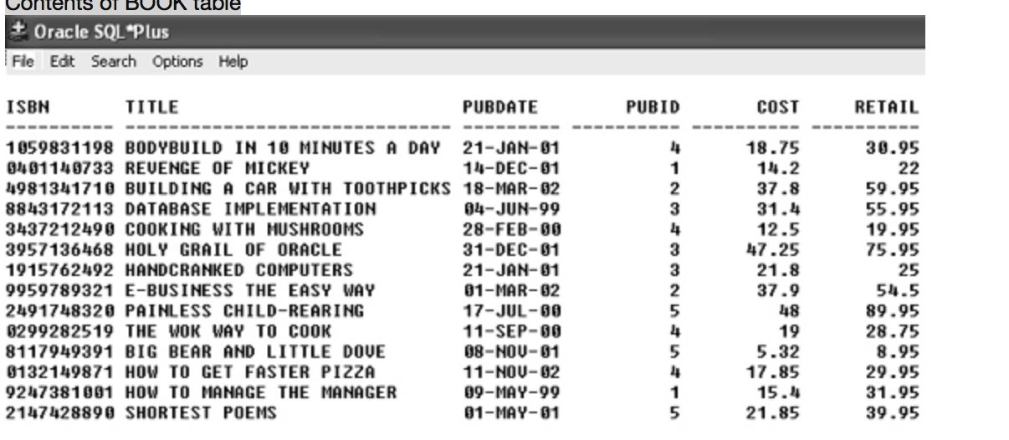

Based upon the contents of the BOOKS table, which of the following SQL statements will retrieve all books published by the publisher assigned Pubid 1?

|  |  |  |
| --- | --- | --- |
|  |  | SELECT * FROM books WHERE pubid LIKE "1"; |
|  |  | **SELECT * FROM books WHERE pubid = 1;** |
|  |  | SELECT * FROM books WHERE pubid > 1; |
|  |  | both a and b |

**QUESTION 127**

1. Contents of BOOK table

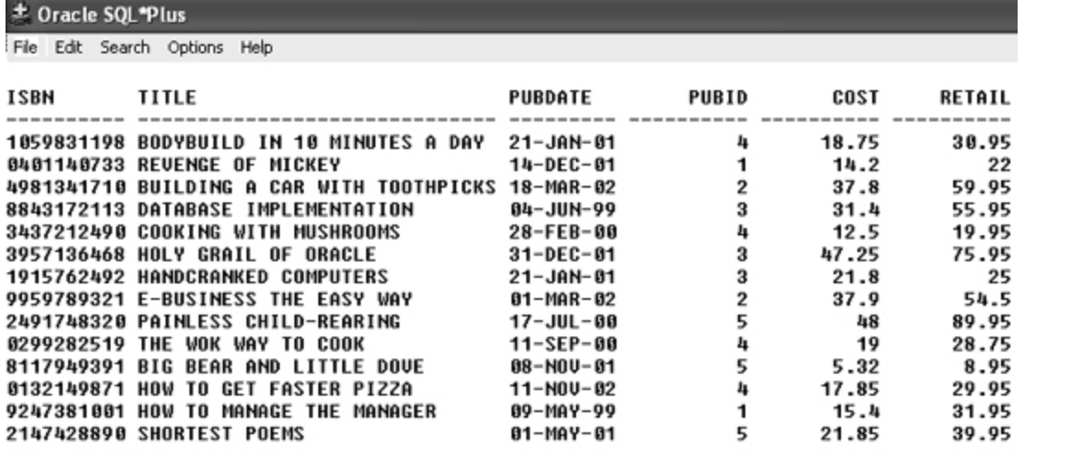

Based upon the contents of the BOOKS table, which of the following queries will retrieve all books published in 2001?

|  |  |  |
| --- | --- | --- |
|  |  | SELECT * FROM books WHERE pubdate BETWEEN '01-JAN-01' AND '31-DEC-01'; |
|  |  | SELECT * FROM books WHERE pubdate LIKE '%01'; |
|  |  | SELECT * FROM books WHERE pubdate >= '01-JAN-01' AND pubdate <= '31-DEC-01'; |
|  |  | ***all of the above*** |

**QUESTION 128**

1. Contents of BOOK table

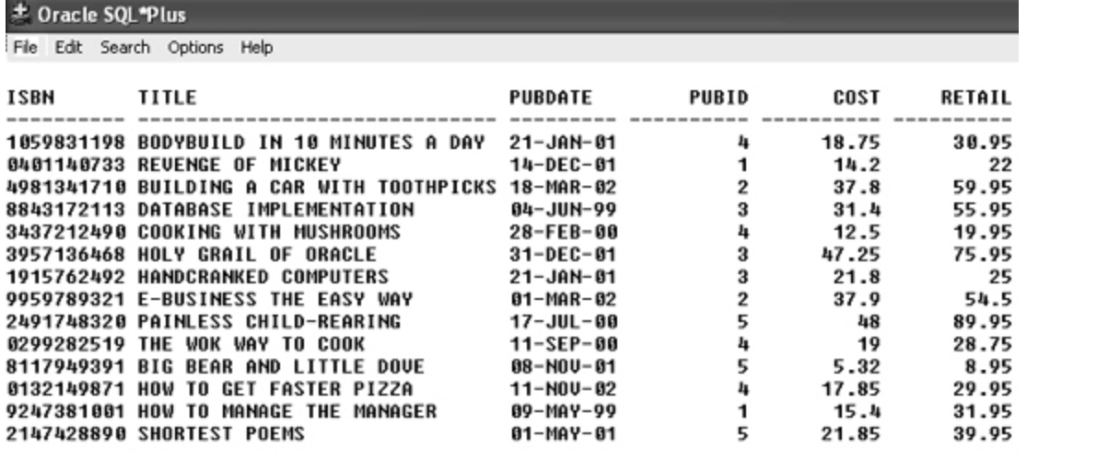

Which of the following queries will retrieve all book titles that are in the Business or Computer category and have a retail price of more than $35.00?

|  |  |  |
| --- | --- | --- |
|  |  | SELECT title FROM books WHERE category = 'BUSINESS' OR 'COMPUTER' AND retail >35; |
|  |  | SELECT title FROM books WHERE category = 'BUSINESS' OR category ='COMPUTER' AND retail >35; |
|  |  | ***SELECT title FROM books WHERE (category = 'BUSINESS' OR category ='COMPUTER' )AND retail >35;*** |
|  |  | SELECT title FROM books WHERE category = 'BUSINESS' OR category ='COMPUTER' AND (retail >35); |

**QUESTION 129**

1. Contents of BOOK table

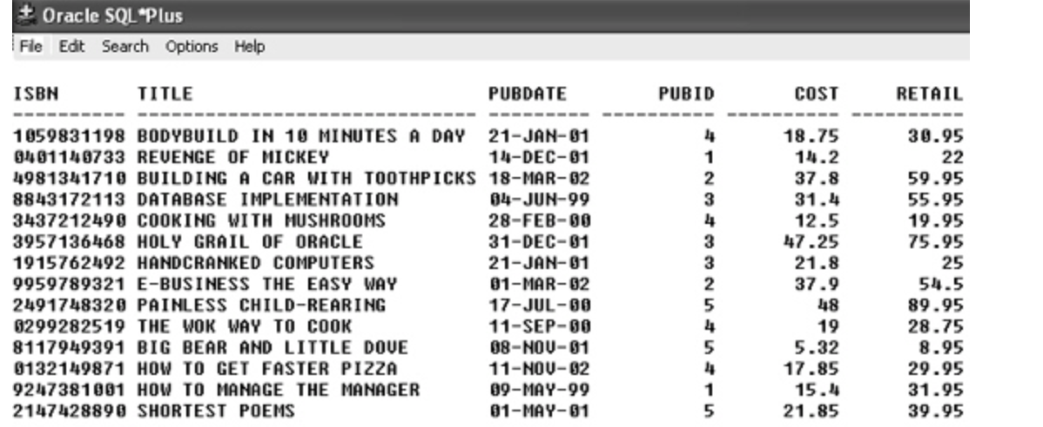

Which of the following queries will return all books that cost at least $25.00?

|  |  |  |
| --- | --- | --- |
|  |  | SELECT * FROM books WHERE cost > $25.00; |
|  |  | **SELECT * FROM books WHERE cost >= 25.00;** |
|  |  | SELECT * FROM books WHERE cost >= $25.00; |
|  |  | none of the above |

**QUESTION 130**

1. Contents of BOOK table

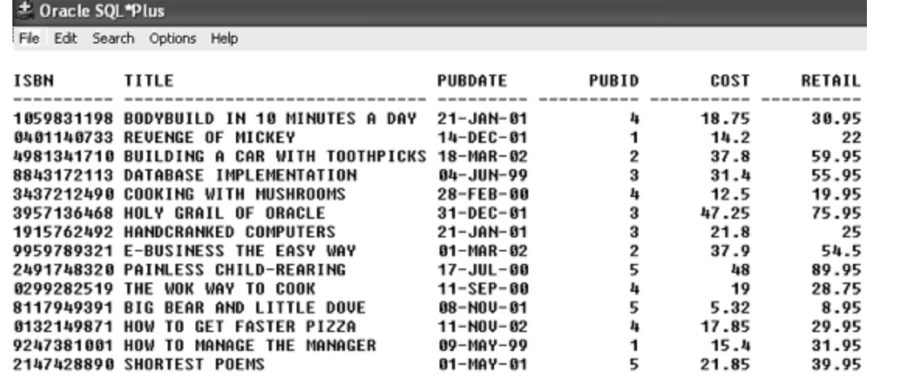

Which of the following queries will display all books stored in the BOOKS table that generate more than 60 percent profit?

|  |  |  |
| --- | --- | --- |
|  |  | SELECT * FROM books WHERE profit > .6; |
|  |  | **SELECT * FROM books WHERE (retail-cost)/cost > .60;** |
|  |  | SELECT * FROM books WHERE (retail-cost)/cost > 60%; |
|  |  | SELECT * FROM books WHERE (retail-cost)/cost > '60'; |

**QUESTION 131**

1. Contents of BOOK table

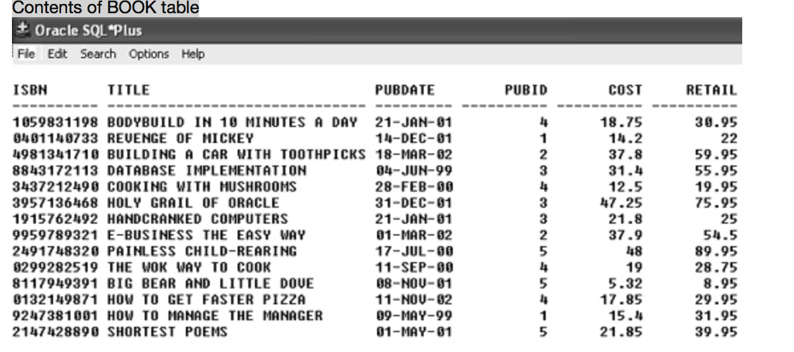

Which of the following queries will retrieve all books stored in the BOOKS table in the Children and Business categories or that have a retail price of at least $42.00?

|  |  |  |
| --- | --- | --- |
|  |  | **?SELECT * FROM books WHERE category = 'CHILDREN' OR category = 'BUSINESS' OR retail >= 42;** |
|  |  | SELECT * FROM books WHERE category IN ('CHILDREN', 'BUSINESS') OR retail => 42; |
|  |  | SELECT * FROM books WHERE category = 'CHILDREN' AND category='BUSINESS' OR retail >=42; |
|  |  | both a and b |



Which of the following queries will list the title and retail price of each book stored in the BOOKS table, sorted in order of the book titles?

|  |  |  |
| --- | --- | --- |
|  |  | SELECT title, retail FROM books ORDERED BY title; |
|  |  | SELECT title, retail FROM books SORTED BY title; |
|  |  | **SELECT title, retail FROM books ORDER BY title;** |
|  |  | SELECT title, retail FROM books SORT BY title; |

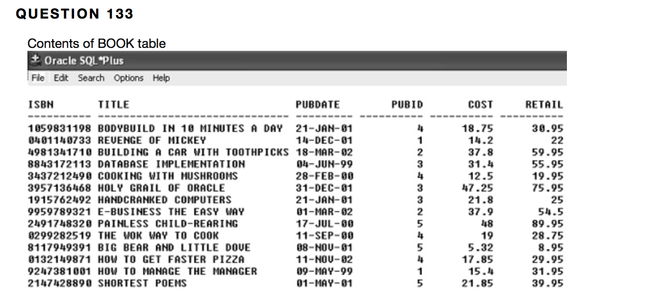

Which of the following queries will list all books stored in the BOOKS table with a retail price of more than $38 sorted by retail price?

|  |  |  |
| --- | --- | --- |
|  |  | SELECT * FROM books WHERE retail >38 SORT BY retail; |
|  |  | SELECT * FROM books WHERE retail >38 SORTED BY retail; |
|  |  | SELECT * FROM books WHERE retail >38 ORDERED BY retail; |
|  |  | **SELECT * FROM books WHERE retail >38 ORDER BY retail;** |

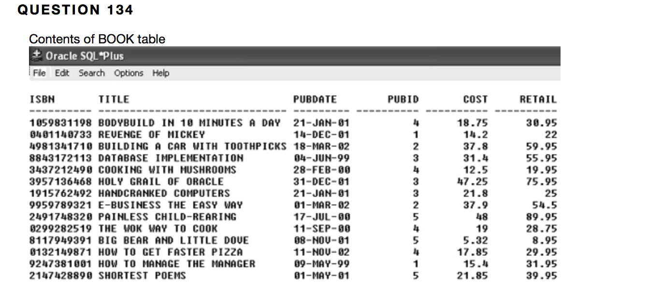

Which of the following queries will display the title and retail price of each book stored in the BOOKS table in order of category and retail price?

|  |  |  |
| --- | --- | --- |
|  |  | **SELECT title, retail price FROM books ORDER BY category, retail;** |
|  |  | SELECT title, retail price FROM books ORDERED BY category, retail; |
|  |  | SELECT title, retail FROM books SORT BY category, retail; |
|  |  | none of the above |

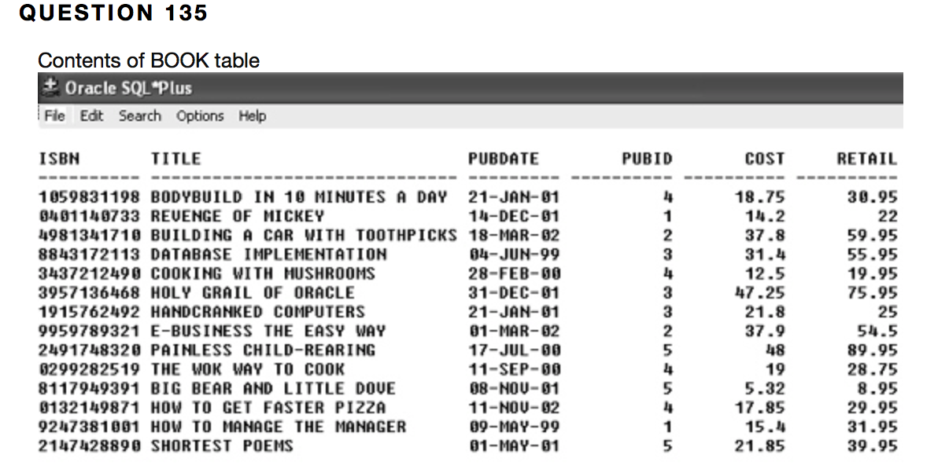

Which of the following queries will return the category and title of all books stored in the BOOKS table presented in order of their category and, for the books in the same category, sort the title of the books in descending order?

|  |  |  |
| --- | --- | --- |
|  |  | SELECT category, title FROM books ORDERED BY 1, 2 desc; |
|  |  | **SELECT category, title FROM books ORDER BY 1 asc, 2 desc;** |
|  |  | SELECT category, title FROM books SORTED BY 1 asc, 2 desc; |
|  |  | SELECT category, title FROM books SORT BY 1, 2 desc; |

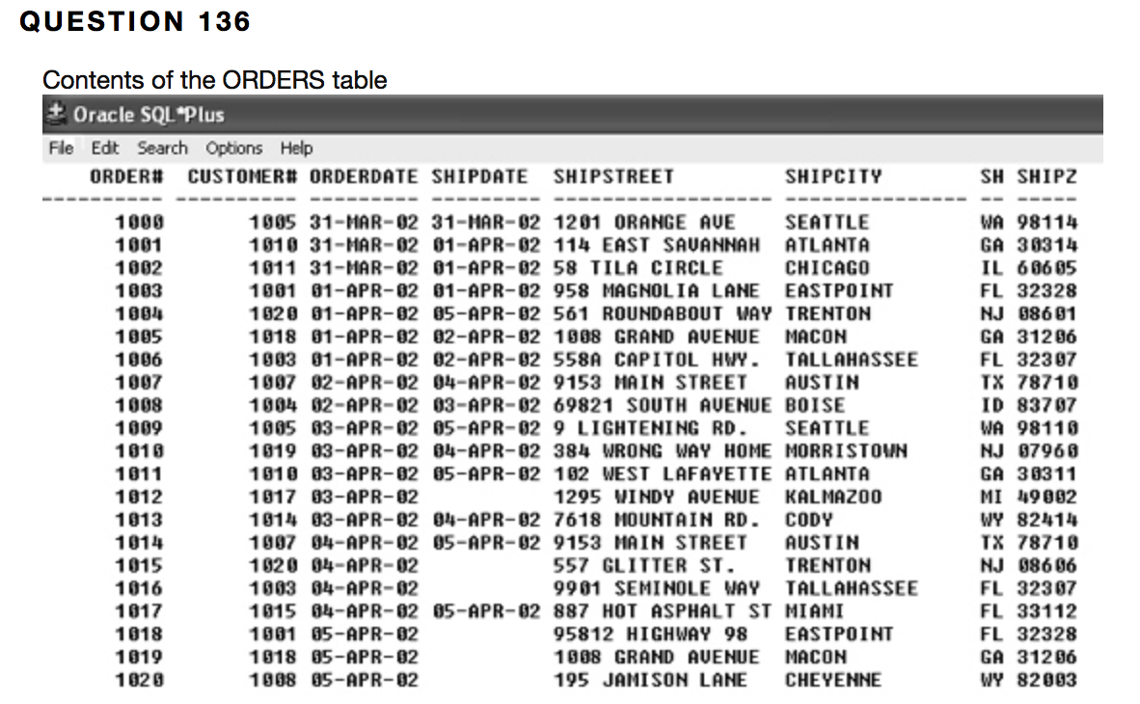

Which of the following SELECT statements will retrieve all orders contained in the ORDERS table that have not yet been shipped to the customer?

|  |  |  |
| --- | --- | --- |
|  |  | SELECT * FROM orders WHERE shipdate = NULL; |
|  |  | SELECT * FROM orders WHERE shipdate > NULL; |
|  |  | SELECT * FROM orders WHERE shipdate LIKE 'NULL'; |
|  |  | **none of the above** |

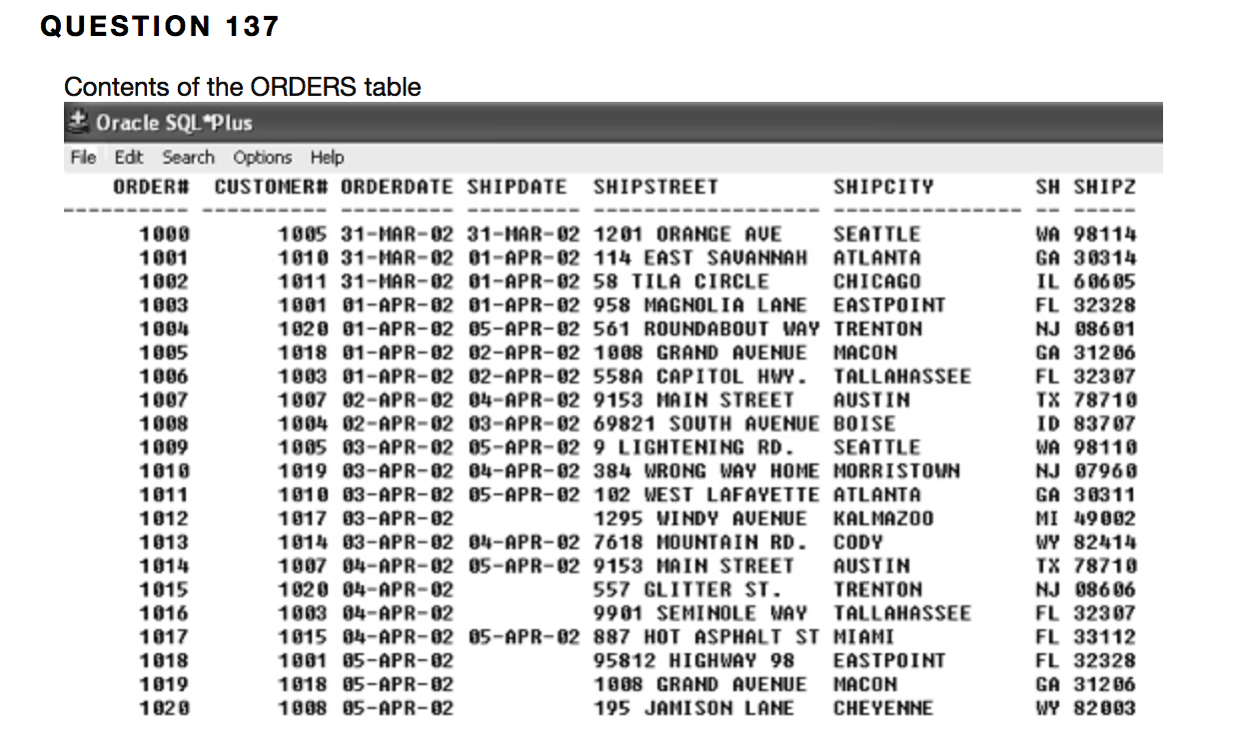

Which of the following SQL statements will display how long it took to ship order# 1007 (based upon when the order was originally placed)?

|  |  |  |
| --- | --- | --- |
|  |  | **SELECT order#, shipdate-orderdate FROM orders WHERE order# = 1007;** |
|  |  | SELECT order#, shipdate-orderdate FROM orders WHERE order# LIKE 1_7%; |
|  |  | SELECT order#, shipdate-orderdate FROM orders WHERE order# = 1_7%; |
|  |  | SELECT order#, shipdate-orderdate FROM orders WHERE order# LIKE '1_7%'; |

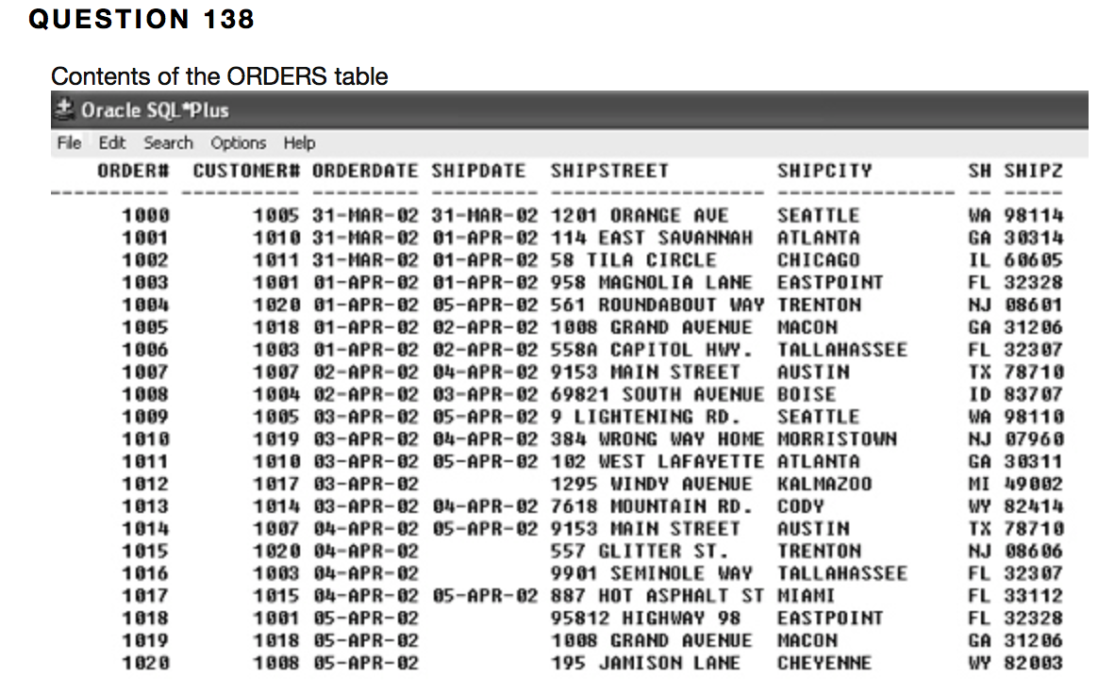

Which of the following SQL statements will display all orders contained in the ORDERS table that have been shipped to the customer?

|  |  |  |
| --- | --- | --- |
|  |  | SELECT * FROM orders WHERE shipdate = 'NOT NULL'; |
|  |  | SELECT * FROM orders WHERE shipdate = NOT NULL; |
|  |  | SELECT * FROM orders WHERE shipdate IS NULL; |
|  |  | **?SELECT * FROM orders WHERE shipdate IS NOT NULL;** |

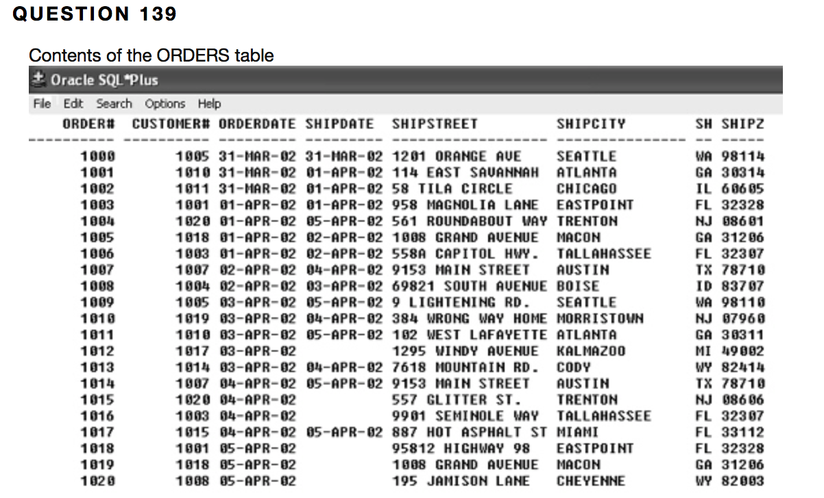

Which of the following SQL statements will list all orders placed by customer# 1020 that have not yet been shipped?

|  |  |  |
| --- | --- | --- |
|  |  | SELECT * FROM orders WHERE customer# = 1020 OR shipdate = NULL; |
|  |  | **SELECT * FROM orders WHERE customer# = 1020 AND shipdate IS NULL;** |
|  |  | SELECT * FROM orders WHERE customer# = 1020 OR shipdate IS NULL; |
|  |  | SELECT * FROM orders WHERE customer# = 1020 AND shipdate = NULL; |

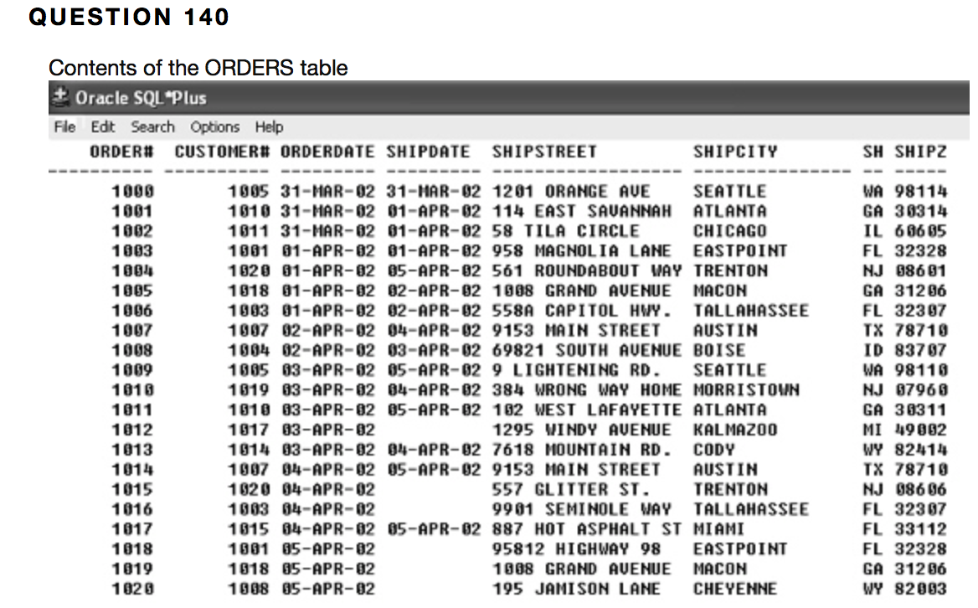

Which of the following queries will not list the orders that have been shipped to Atlanta or Seattle?

|  |  |  |
| --- | --- | --- |
|  |  | SELECT * FROM orders WHERE shipcity = 'ATLANTA' OR shipcity = 'SEATTLE'; |
|  |  | SELECT * FROM orders WHERE shipcity IN ( 'ATLANTA' , 'SEATTLE'); |
|  |  | **SELECT * FROM orders WHERE shipcity = 'Atlanta' OR shipcity = 'Seattle';** |
|  |  | SELECT * FROM orders WHERE shipcity LIKE 'AT%' OR shipcity LIKE 'SEA%'; |

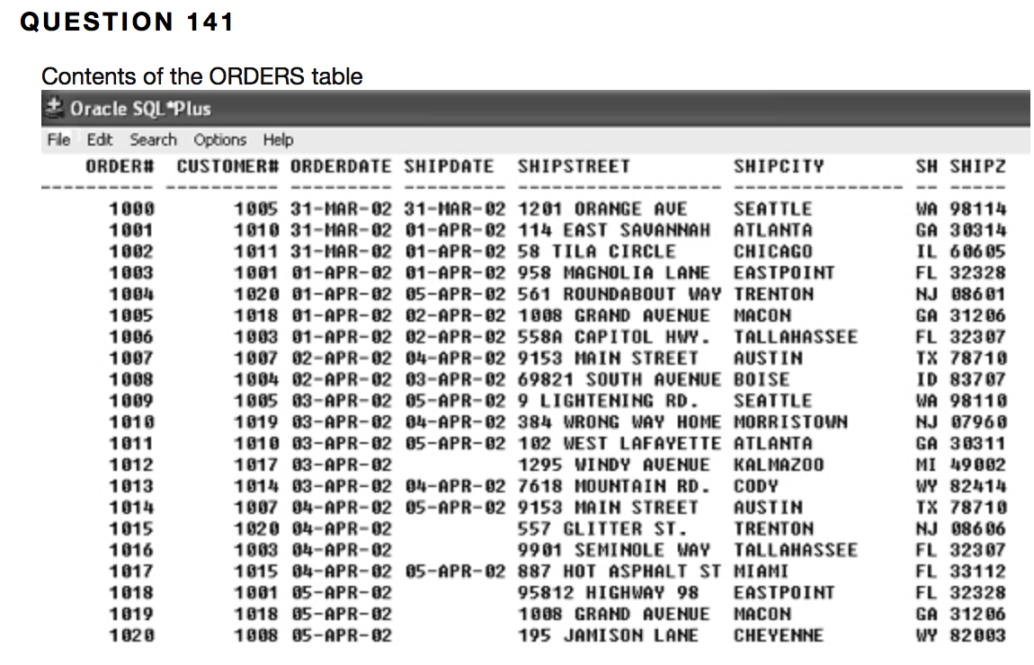

Which of the following queries will display all orders that were not shipped for at least three days after the order was received?

|  |  |  |
| --- | --- | --- |
|  |  | SELECT * FROM orders WHERE shipdate-orderdate => 3; |
|  |  | **SELECT * FROM orders WHERE shipdate-orderdate >= 3;** |
|  |  | SELECT * FROM orders WHERE NOT shipdate-orderdate => 3; |
|  |  | SELECT * FROM orders WHERE NOT shipdate-orderdate >= 3; |

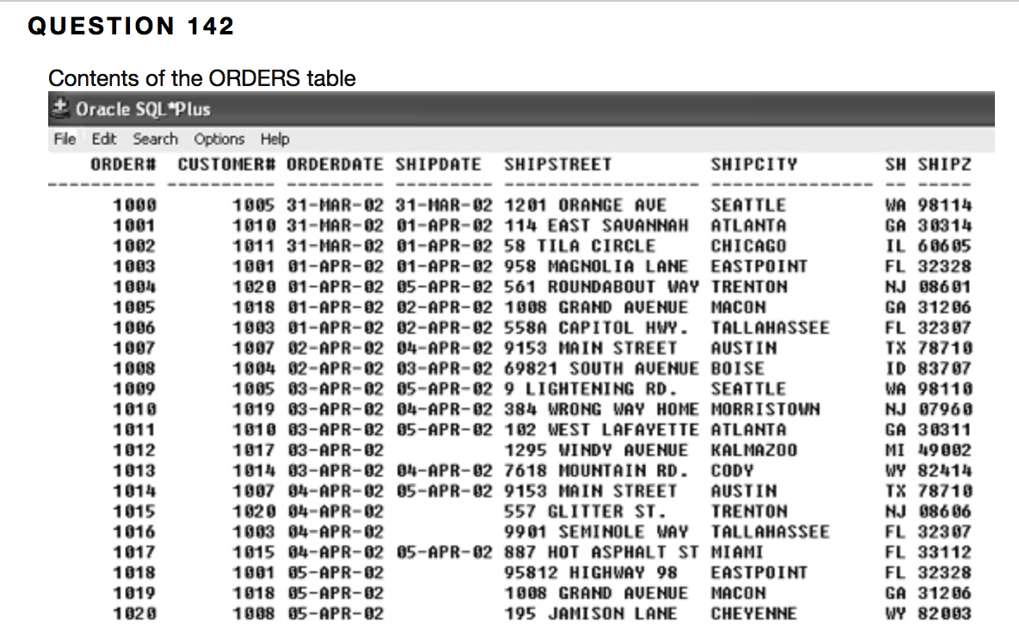

Which of the following queries will return all orders shipped within three days after the order was received?

|  |  |  |
| --- | --- | --- |
|  |  | SELECT * FROM orders WHERE shipdate-orderdate >= 3; |
|  |  | SELECT * FROM orders WHERE shipdate-orderdate =< 3; |
|  |  | SELECT * FROM orders WHERE NOT shipdate-orderdate => 3; |
|  |  | **SELECT * FROM orders WHERE shipdate-orderdate <= 3;** |

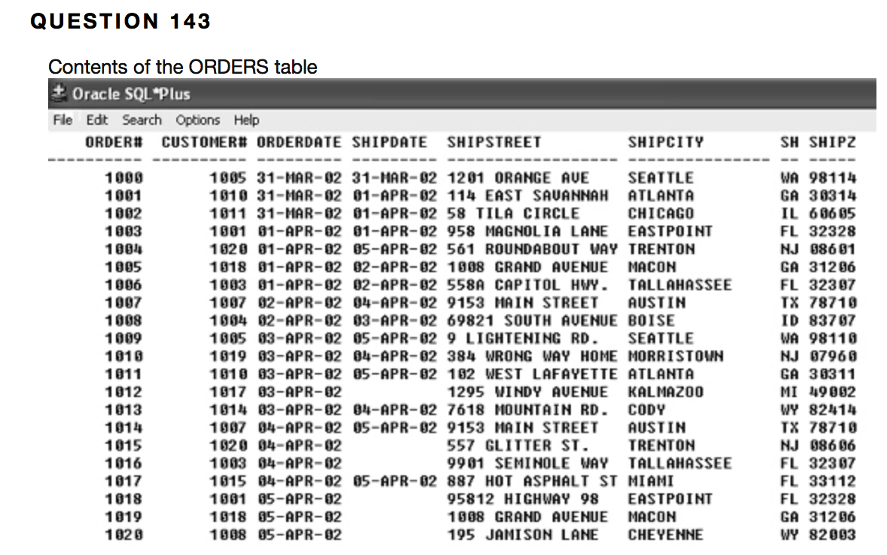

Which of the following queries will display all orders placed in the month of March?

|  |  |  |
| --- | --- | --- |
|  |  | **SELECT * FROM orders WHERE orderdate LIKE '%Mar%';** |
|  |  | SELECT * FROM orders WHERE orderdate LIKE 'Mar%'; |
|  |  | SELECT * FROM orders WHERE orderdate LIKE "%Mar%"; |
|  |  | none of the above |

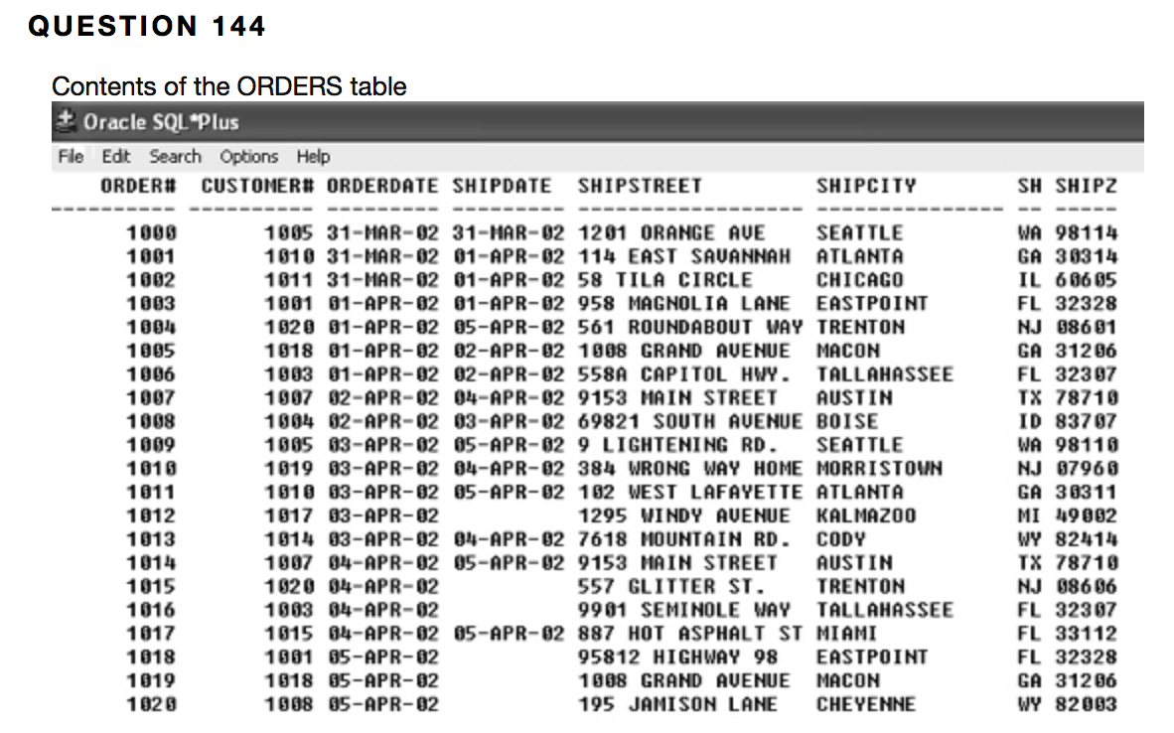

Which of the following queries will display all orders shipped between April 4, 2003 and April 5, 2003?

|  |  |  |
| --- | --- | --- |
|  |  | SELECT * FROM orders WHERE shipdate <= '04-APR-03' AND shipdate >= '05-APR-03'; |
|  |  | SELECT * FROM orders WHERE shipdate BETWEEN '04-APR-03' AND '05-APR-03'; |
|  |  | SELECT * FROM orders WHERE shipdate >= ‘04-APR-03’ AND shipdate <= ‘05-APR-03’; |
|  |  | **both b and c** |

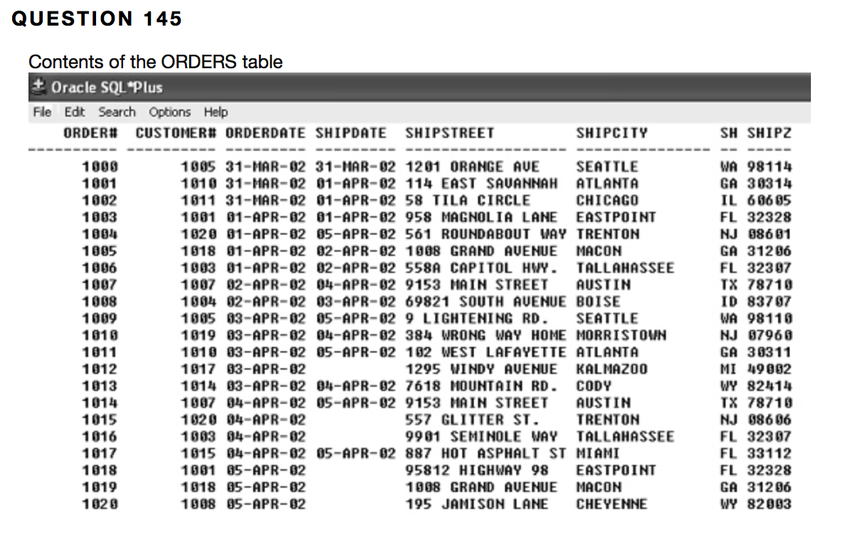

Which of the following queries will list all orders contained in the ORDERS table that have been shipped based upon the customer# and order#?

|  |  |  |
| --- | --- | --- |
|  |  | SELECT * FROM orders WHERE shipdate IS NOT NULL ORDER BY customer#, order#; |
|  |  | **(right one)SELECT * FROM orders WHERE shipdate IS NULL ORDER BY customer#, order#;** |
|  |  | ***(wrong answer)SELECT * FROM orders WHERE shipdate IS NOT NULL ORDERED BY customer#, order#;*** |
|  |  | SELECT * FROM orders WHERE shipdate IS  NOT NULL SORTED BY customer#, order#; |

**QUESTION 146**

1. Which of the following is not considered a group function?

|  |  |  |
| --- | --- | --- |
|  |  | **TRUNC** |
|  |  | MIN |
|  |  | COUNT |
|  |  | SUM |

**1 points**

**QUESTION 147**

1. Functions that return one result per group of rows are called ____ functions.

|  |  |  |
| --- | --- | --- |
|  |  | group |
|  |  | multiple-row |
|  |  | aggregate |
|  |  | **all of the above** |

**1 points**

**QUESTION 148**

1. The default keyword for group functions is ____.

|  |  |  |
| --- | --- | --- |
|  |  | **ALL** |
|  |  | DISTINCT |
|  |  | INCLUDENULLS |
|  |  | NONULLS |

**1 points**

**QUESTION 149**

1. The SUM function can only be used with ____ data.

|  |  |  |
| --- | --- | --- |
|  |  | **numeric** |
|  |  | character |
|  |  | date |
|  |  | alphanumeric |

**1 points**

**QUESTION 150**

1. The ____ function is used to calculate the total amount stored in a numeric field.

|  |  |  |
| --- | --- | --- |
|  |  | TOTAL |
|  |  | **SUM** |
|  |  | AVERAGE |
|  |  | ADD |

**1 points**

**QUESTION 151**

1. If the DISTINCT keyword is not included in the SUM function, the ____ keyword will be assumed.

|  |  |  |
| --- | --- | --- |
|  |  | UNIQUE |
|  |  | **ALL** |
|  |  | RANDOM |
|  |  | none of the above |

**1 points**

**QUESTION 152**

1. The ____ function calculates the average of the numeric values in a specified column.

|  |  |  |
| --- | --- | --- |
|  |  | **AVG** |
|  |  | AVERAGE |
|  |  | MEAN |
|  |  | AG |

**1 points**

**QUESTION 153**

1. The ____ function can be used to determine the number of rows containing a specified value.

|  |  |  |
| --- | --- | --- |
|  |  | TOTAL |
|  |  | SUM |
|  |  | **COUNT** |
|  |  | ADD |

**1 points**

**QUESTION 154**

1. If the DISTINCT keyword is not included in the AVG function, the ____ keyword will be assumed.

|  |  |  |
| --- | --- | --- |
|  |  | **ALL** |
|  |  | UNIQUE |
|  |  | GROUP |
|  |  | none of the above |

**1 points**

**QUESTION 155**

1. The AVG function can be used with ____ values.

|  |  |  |
| --- | --- | --- |
|  |  | **numeric** |
|  |  | character |
|  |  | date |
|  |  | all of the above |

**1 points**

**QUESTION 156**

1. Which of the following cannot be used with date columns?

|  |  |  |
| --- | --- | --- |
|  |  | MIN |
|  |  | MAX |
|  |  | ***AVG*** |
|  |  | all of the above |

**1 points**

**QUESTION 157**

1. The ____ function can be used to include NULL values in the calculation.

|  |  |  |
| --- | --- | --- |
|  |  | AVG |
|  |  | SUM |
|  |  | NULL |
|  |  | ***COUNT*** |

**1 points**

**QUESTION 158**

1. The ____ function can be used to determine the number of rows meeting a specific condition.

|  |  |  |
| --- | --- | --- |
|  |  | ADD |
|  |  | SUM |
|  |  | **COUNT** |
|  |  | TOTAL |

**1 points**

**QUESTION 159**

1. Which of the following is a correct statement?

|  |  |  |
| --- | --- | --- |
|  |  | ***An asterisk can be used as the argument for the COUNT function to include NULL values in the results.*** |
|  |  | The NULL keyword can be included in the argument of the COUNT function to include NULL values in the results. |
|  |  | The ALL keyword can be included in the argument of the COUNT function to include NULL values in the results. |
|  |  | The INCLUDE NULLS keywords can be included in the argument for the COUNT function to include NULL values in the results. |

**1 points**

**QUESTION 160**

1. The ____ function can be used to determine the largest value stored in a specified column.

|  |  |  |
| --- | --- | --- |
|  |  | MAXIMUM |
|  |  | **MAX** |
|  |  | LARGE |
|  |  | LARGEST |

**1 points**

**QUESTION 161**

1. The MAX function can be used with which type of columns?

|  |  |  |
| --- | --- | --- |
|  |  | **numeric** |
|  |  | date |
|  |  | character |
|  |  | **all of the above** |

**1 points**

**QUESTION 162**

1. The ____ function returns the smallest value in a specified column.

|  |  |  |
| --- | --- | --- |
|  |  | LOW |
|  |  | LOWEST |
|  |  | **MIN** |
|  |  | MINIMUM |

**1 points**

**QUESTION 163**

1. The MIN function can be only be used with ____ columns.

|  |  |  |
| --- | --- | --- |
|  |  | numeric |
|  |  | character |
|  |  | date |
|  |  | **all of the above** |

**1 points**

**QUESTION 164**

1. The ____ clause is used to indicate that groups should be created.

|  |  |  |
| --- | --- | --- |
|  |  | ORDER BY |
|  |  | **GROUP BY** |
|  |  | AGGREGATED |
|  |  | GROUPING |

**1 points**

**QUESTION 165**

1. Which of the following is a valid statement?

|  |  |  |
| --- | --- | --- |
|  |  | ?The ORDER BY clause cannot be used in a SELECT statement containing a GROUP BY clause. |
|  |  | Data returned from a GROUP BY clause will automatically be sorted in descending order. |
|  |  | ***Column aliases cannot be used in a GROUP BY clause.*** |
|  |  | Columns referenced in the GROUP BY clause must also be contained in the SELECT clause. |

**1 points**

**QUESTION 166**

1. If a(n) ____ is used in a SELECT clause, it must also be included in the GROUP BY clause.

|  |  |  |
| --- | --- | --- |
|  |  | ?group function |
|  |  | single-row function |
|  |  | ***individual column*** |
|  |  | all of the above |

**1 points**

**QUESTION 167**

1. The ____ clause is used to restrict the groups returned by a query.

|  |  |  |
| --- | --- | --- |
|  |  | FROM |
|  |  | WHERE |
|  |  | **HAVING** |
|  |  | GROUP BY |

**1 points**

**QUESTION 168**

1. Which of the following lines of the SQL statement contains an error?  
                          1  SELECT title, MAX(retail)  
                          2  FROM books  
                          3  WHERE retail > 30  
                          4  AND pubid = 1  
                          5  ORDER BY title;

|  |  |  |
| --- | --- | --- |
|  |  | Line 2 |
|  |  | Line 3 |
|  |  | Line 4 |
|  |  | **Line 5** |

**1 points**

**QUESTION 169**

1. A(n) ____ clause cannot include a group function.

|  |  |  |
| --- | --- | --- |
|  |  | **WHERE** |
|  |  | HAVING |
|  |  | ORDER BY |
|  |  | both a and c |

**1 points**

**QUESTION 170**

1. If a SELECT statement contains HAVING, GROUP BY, and WHERE clauses, the ____ clause will be processed first.

|  |  |  |
| --- | --- | --- |
|  |  | HAVING |
|  |  | GROUP BY |
|  |  | **WHERE** |
|  |  | ORDER BY |

**1 points**

**QUESTION 171**

1. If a SELECT statement contains HAVING, GROUP BY, and WHERE clauses, the ____ clause will be processed last.

|  |  |  |
| --- | --- | --- |
|  |  | **HAVING** |
|  |  | GROUP BY |
|  |  | WHERE |
|  |  | SELECT |

**1 points**

**QUESTION 172**

1. Which of the following indicates the processing order for the indicated clauses?

|  |  |  |
| --- | --- | --- |
|  |  | WHERE, HAVING, GROUP BY |
|  |  | GROUP BY, HAVING, WHERE |
|  |  | **WHERE, GROUP BY, HAVING** |
|  |  | HAVING, WHERE, GROUP BY |

**1 points**

**QUESTION 173**

1. If the output is to be restricted based upon a group function, a(n) ____ clause must be included in the SQL statement.

|  |  |  |
| --- | --- | --- |
|  |  | GROUP BY |
|  |  | WHERE |
|  |  | **HAVING** |
|  |  | ORDER BY |

**1 points**

**QUESTION 174**

1. Which of the following is a valid SQL statement?

|  |  |  |
| --- | --- | --- |
|  |  | ***SELECT SUM(quantity*retail) "Total Sales" FROM orders JOIN orderitems ON orders.order# = orderitems.order# JOIN books ON orderitems ON orderitems.ISBN = books.ISBN WHERE orderdate = '02-APR-03';*** |
|  |  | SELECT SUM(quantity*retail) "Total Sales" FROM orders JOIN orderitems ON orders.order# = orderitems.order# JOIN books ON orderitems ON orderitems.ISBN = books.ISBN HAVING orderdate = '02-APR-03'; |
|  |  | SELECT customer#, SUM(quantity*retail) "Total Sales" FROM orders JOIN orderitems ON orders.order# = orderitems.order# JOIN books ON orderitems ON orderitems.ISBN = books.ISBN HAVING orderdate = '02-APR-03'; |
|  |  | SELECT customer#, SUM(quantity*retail) "Total Sales" FROM orders JOIN orderitems ON orders.order# = orderitems.order# JOIN books ON orderitems ON orderitems.ISBN = books.ISBN HAVING orderdate = '02-APR-03' GROUP BY customer#; |

**1 points**

**QUESTION 175**

1. Group functions can be nested to a depth of ____.

|  |  |  |
| --- | --- | --- |
|  |  | **2** |
|  |  | 25 |
|  |  | 255 |
|  |  | 30 |

**1 points**

**QUESTION 176**

1. A group function can be nested inside a(n)____.

|  |  |  |
| --- | --- | --- |
|  |  | group function |
|  |  | single-row function |
|  |  | order function |
|  |  | **both a and b** |

**1 points**

**QUESTION 177**

1. Which of the following is a valid statement?

|  |  |  |
| --- | --- | --- |
|  |  | A single-row function can be nested inside a group function. |
|  |  | Group functions can be nested inside other group functions. |
|  |  | Group functions can be nested inside single-row functions. |
|  |  | ***all of the above*** |

**1 points**

**QUESTION 178**

1. The ____ function calculates the standard deviation for a specific set of data.

|  |  |  |
| --- | --- | --- |
|  |  | STDDEVIATION |
|  |  | STD |
|  |  | **STDDEV** |
|  |  | STANDARDDEV |

**1 points**

**QUESTION 179**

1. If the DISTINCT keyword is not included in the STDDEV function, the ____ keyword will be assumed.

|  |  |  |
| --- | --- | --- |
|  |  | UNIQUE |
|  |  | **ALL** |
|  |  | NONULLS |
|  |  | none of the above |

**1 points**

**QUESTION 180**

1. The STDDEV can be used with ____ columns.

|  |  |  |
| --- | --- | --- |
|  |  | **numeric** |
|  |  | character |
|  |  | date |
|  |  | all of the above |

**1 points**

**QUESTION 181**

1. The ____ function is based upon the concept of a normal distribution.

|  |  |  |
| --- | --- | --- |
|  |  | MIN |
|  |  | MAX |
|  |  | SUM |
|  |  | **STDDEV** |

**1 points**

**QUESTION 182**

1. The ____ function is used to determine how widely data are spread out within a group.

|  |  |  |
| --- | --- | --- |
|  |  | STDDEV |
|  |  | STANDARDDEV |
|  |  | **VARIANCE** |
|  |  | VAR |

**1 points**

**QUESTION 183**

1. If the DISTINCT keyword is not included in the VARIANCE function, the ____ keyword will be assumed.

|  |  |  |
| --- | --- | --- |
|  |  | UNIQUE |
|  |  | **ALL** |
|  |  | NULLS ONLY |
|  |  | NONULLS |

**1 points**

**QUESTION 184**

1. The VARIANCE function can be used with ____ columns.

|  |  |  |
| --- | --- | --- |
|  |  | alphanumeric |
|  |  | **numeric** |
|  |  | date |
|  |  | none of the above |

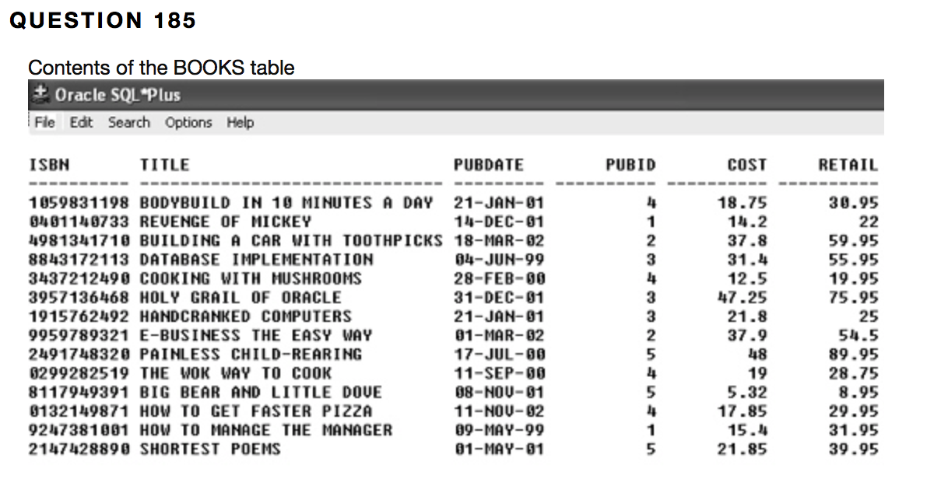

Based upon the contents of the BOOKS tables, which of the following SQL statements will return the number of categories contained in the table?

|  |  |  |
| --- | --- | --- |
|  |  | **SELECT COUNT(DISTINCT category) FROM books;** |
|  |  | SELECT DISTINCT COUNT(category) FROM books; |
|  |  | SELECT DISTINCT (COUNT(category)) FROM books; |
|  |  | SELECT DISTINCT COUNT(category) FROM books; |

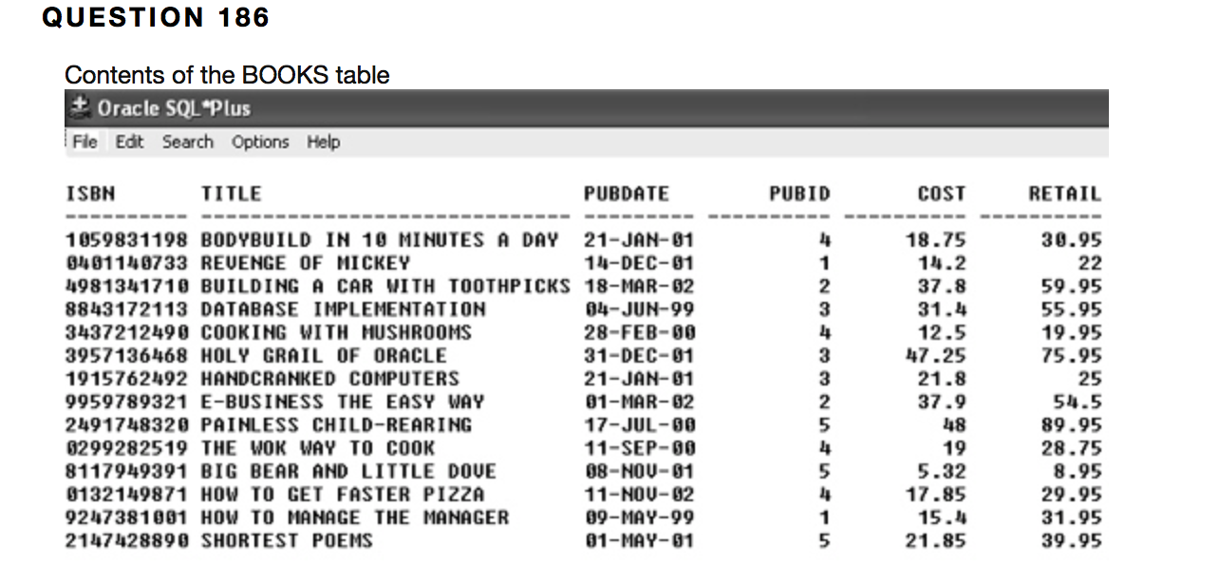

Based on the contents of the BOOKS table, which of the following is a valid SQL statement?

|  |  |  |
| --- | --- | --- |
|  |  | SELECT AVERAGE(retail-cost) "Average Profit" FROM books GROUP BY category; |
|  |  | SELECT category, AVERAGE(retail-cost) "Average Profit" FROM books GROUP BY category; |
|  |  | **SELECT category, AVG(retail-cost) "Average Profit" FROM books GROUP BY category;** |
|  |  | SELECT category, AVG(retail-cost) "Average Profit" FROM books WHERE retail-cost > 25; |

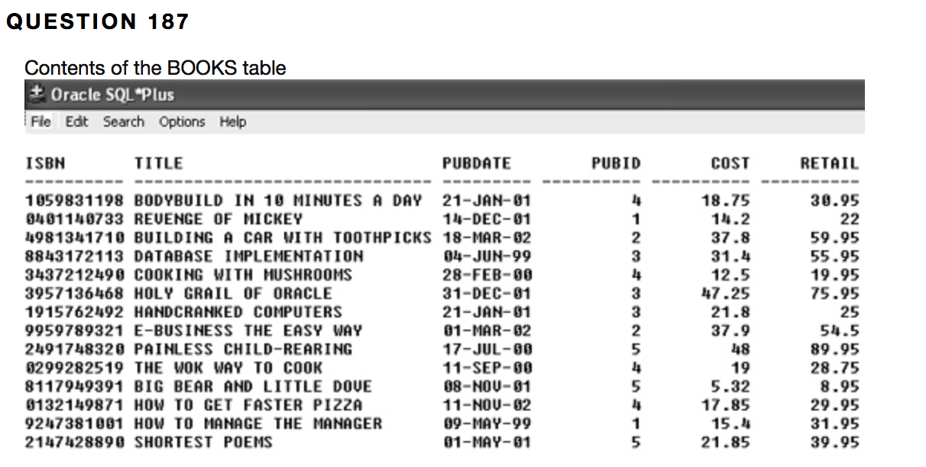

Based on the contents of the BOOKS table, which of the following SQL statements will return the total profit generated by books in the COOKING category?

|  |  |  |
| --- | --- | --- |
|  |  | SELECT TOTAL(retail-cost) FROM books WHERE category = 'COOKING'; |
|  |  | SELECT TOTAL(retail-cost) FROM books GROUP BY category; |
|  |  | **SELECT SUM(retail-cost) FROM books WHERE category = 'COOKING';** |
|  |  | SELECT SUM(retail-cost) FROM books GROUP BY category = 'COOKING'; |

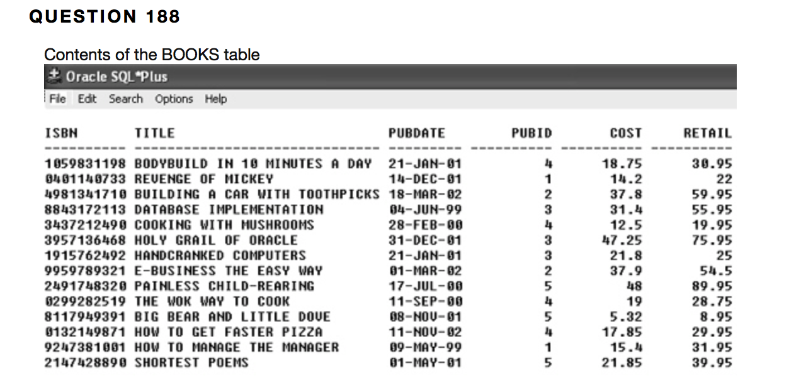

Based upon the contents of the BOOKS table, which of the following will determine the number of books in the computer category?

|  |  |  |
| --- | --- | --- |
|  |  | SELECT SUM(category) FROM books WHERE category = 'COMPUTER'; |
|  |  | SELECT TOTAL(*) FROM books WHERE category = 'COMPUTER'; |
|  |  | **SELECT COUNT(category) FROM books WHERE category = 'COMPUTER';** |
|  |  | none of the above |

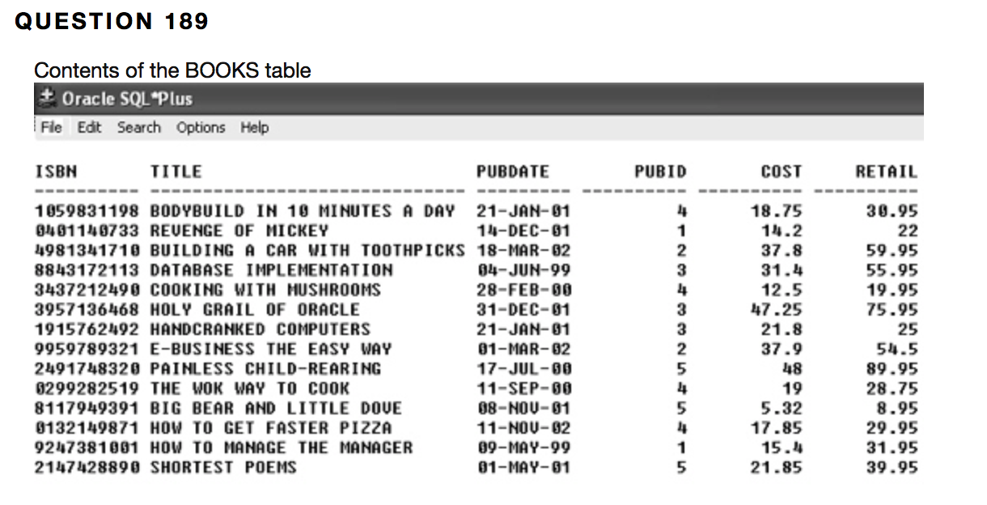

Based upon the contents of the BOOKS table, which of the following will find the retail price of the most expensive book in the COMPUTER category?

|  |  |  |
| --- | --- | --- |
|  |  | SELECT MAX(retail) FROM books GROUP BY category; |
|  |  | SELECT MAXIMUM(retail) FROM books WHERE category = 'COMPUTER'; |
|  |  | ***SELECT MAX(retail) FROM books WHERE category = 'COMPUTER';*** |
|  |  | SELECT MAXIMUM(retail) FROM books HAVING category = 'COMPUTER'; |

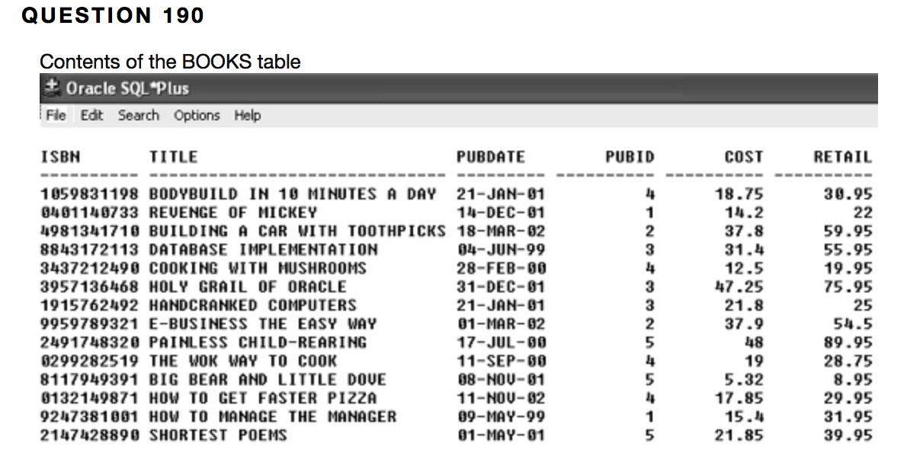

Based on the contents of the BOOKS table, which of the following will display the date of the book with the earliest publication date?

|  |  |  |
| --- | --- | --- |
|  |  | **SELECT MIN(pubdate) FROM books;** |
|  |  | SELECT title FROM books WHERE pubdate = MIN(pubdate); |
|  |  | SELECT title FROM books WHERE pubdate = MINIMUM(pubdate); |
|  |  | SELECT MINIMUM(pubdate) FROM books; |

**QUESTION 191**

1. Which of the following can be used with character data?

|  |  |  |
| --- | --- | --- |
|  |  | MIN |
|  |  | MAX |
|  |  | COUNT |
|  |  | **all of the above** |

**1 points**

**QUESTION 192**

1. Which of the following can be used with date columns?

|  |  |  |
| --- | --- | --- |
|  |  | MIN |
|  |  | MAX |
|  |  | COUNT |
|  |  | **all of the above** |

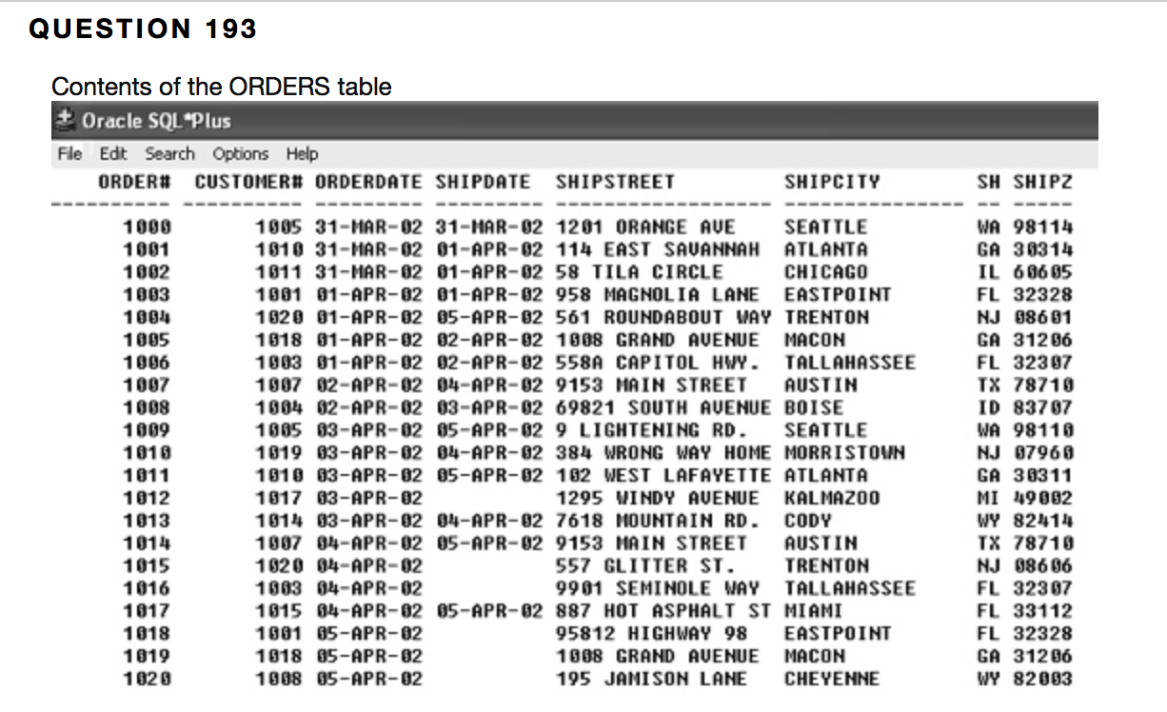

Based on the contents of the ORDERS table, which of the following SQL statements will display the number of orders that have not been shipped?

|  |  |  |
| --- | --- | --- |
|  |  | SELECT order#, COUNT(shipdate) FROM orders WHERE shipdate IS NULL; |
|  |  | SELECT order#, COUNT(shipdate) FROM orders WHERE shipdate IS NULL GROUP BY order#; |
|  |  | SELECT COUNT(shipdate) FROM orders WHERE shipdate IS NULL; |
|  |  | **SELECT COUNT(*) FROM orders WHERE shipdate IS NULL;** |

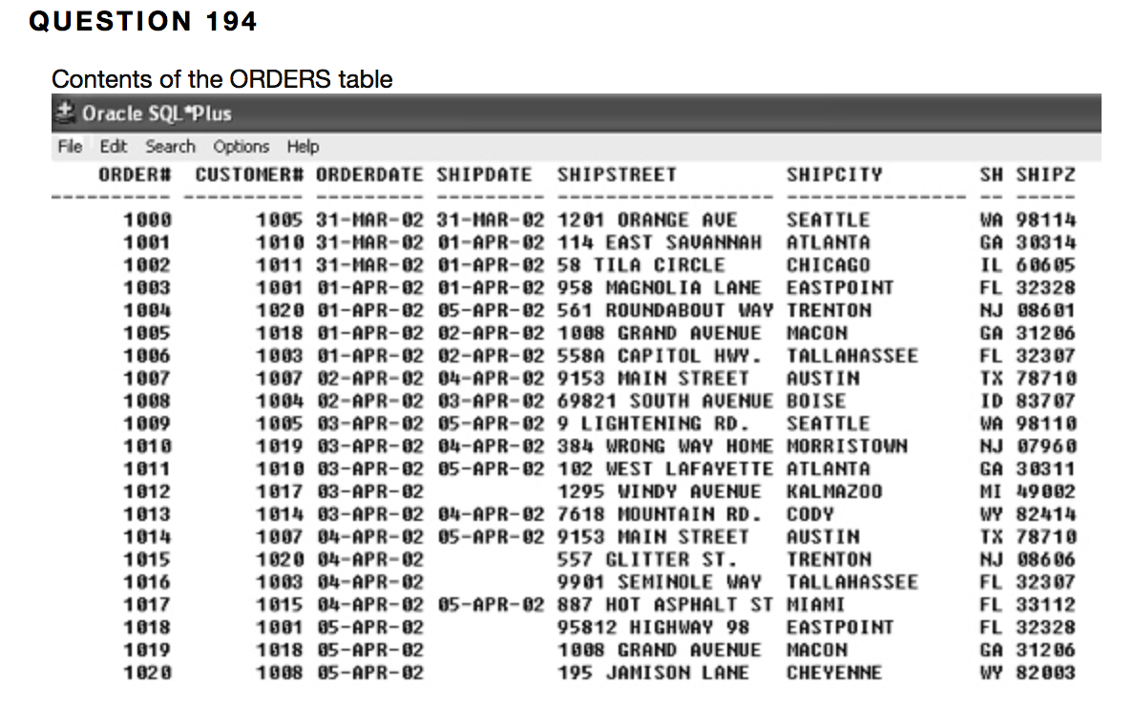

Based on the contents of the ORDERS table, which of the following SELECT statements will determine the number of orders placed by each customer?

|  |  |  |
| --- | --- | --- |
|  |  | SELECT COUNT(DISTINCT(customer#)) FROM orders; |
|  |  | SELECT COUNT(*) FROM orders; |
|  |  | **SELECT customer#, COUNT(customer#) FROM orders GROUP BY customer#;** |
|  |  | none of the above |

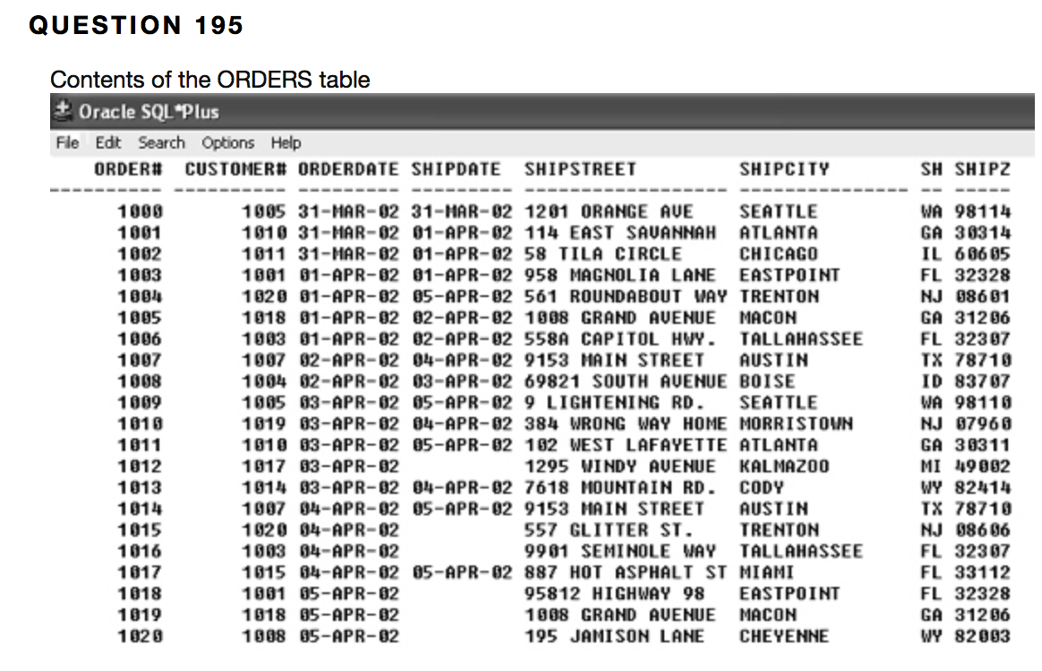

Based upon the contents of the ORDERS table, which of the following will display how many orders were shipped to each state?

|  |  |  |
| --- | --- | --- |
|  |  | SELECT shipstate, COUNT(*) FROM orders; |
|  |  | SELECT shipstate, COUNT(customer#) FROM orders; |
|  |  | SELECT shipstate, COUNT(*) FROM orders HAVING COUNT(*) >0; |
|  |  | **SELECT shipstate, COUNT(*) FROM orders GROUP BY shipstate;** |

**QUESTION 1**

1. The SQL command that lets you insert data into a table, one row at a time, is ____.

|  |  |  |
| --- | --- | --- |
|  |  | ***INSERT*** |
|  |  | SELECT |
|  |  | COMMIT |
|  |  | UPDATE |

**QUESTION 2**

1. Which command would you use when making corrections to the PRODUCT table?

|  |  |  |
| --- | --- | --- |
|  |  | CHANGE PRODUCT SET P_INDATE = '01/18/2004' WHERE P_CODE = '13-Q2/P2'; |
|  |  | ROLLBACK PRODUCT SET P_INDATE = '01/18/2004' WHERE P_CODE = '13-Q2/P2'; |
|  |  | EDIT PRODUCT SET P_INDATE = '01/18/2004' WHERE P_CODE = '13-Q2/P2'; |
|  |  | ***UPDATE PRODUCT SET P_INDATE = '01/18/2004' WHERE P_CODE = '13-Q2/P2';*** |

**QUESTION 3**

1. Which command would be used to delete the table row where the P_Code = '2238/QPD'?

|  |  |  |
| --- | --- | --- |
|  |  | ***DELETE FROM PRODUCT WHERE P_CODE = '2238/QPD';*** |
|  |  | REMOVE FROM PRODUCT WHERE P_CODE = '2238/QPD'; |
|  |  | ERASE FROM PRODUCT WHERE P_CODE = '2238/QPD'; |
|  |  | ROLLBACK FROM PRODUCT WHERE P_CODE = '2238/QPD'; |

**QUESTION 4**

1. To delete a row from the PRODUCT table, use the ____ command.

|  |  |  |
| --- | --- | --- |
|  |  | KILL |
|  |  | ***DELETE*** |
|  |  | DROP |
|  |  | ERASE |

**1 points**

**QUESTION 5**

1. Before the COMMIT command is used, you can retrieve deleted records by using the ____ command.

|  |  |  |
| --- | --- | --- |
|  |  | UNDELETE |
|  |  | ***ROLLBACK*** |
|  |  | UNSAVE |
|  |  | RESTORE |

**1 points**

**QUESTION 6**

1. Given the following:  
   UPDATE tablename  
   "*****"  
   [WHERE conditionlist];  
   What command replaces the ***** in the above statement?

|  |  |  |
| --- | --- | --- |
|  |  | ***SET columnname = expression*** |
|  |  | columnname = expression |
|  |  | expression = columnname |
|  |  | LET columnname = expression |

**1 points**

**QUESTION 7**

1. Some RDBMSs (like Oracle) will automatically ____ data changes when issuing data definition commands.

|  |  |  |
| --- | --- | --- |
|  |  | ROLLBACK |
|  |  | ***COMMIT*** |
|  |  | UPDATE |
|  |  | INVOKE |

**QUESTION 8**

1. What happens when you issue the DELETE FROM tablename command without specifying a where condition?

|  |  |  |
| --- | --- | --- |
|  |  | no rows will be deleted |
|  |  | the first all rows will be deleted row will be deleted |
|  |  | the last row will be deleted |
|  |  | ***all rows will be deleted*** |

1. Using ACCESS SQL standards and given the following CREATE TABLE command:  
   CREATE TABLE STUDENT  
   (SNO NUMBER(9),  
   STUDENT_NAME VARCHAR2(20) NOT NULL,  
   MAJOR VARCHAR2(3) NOT NULL,  
   QPA NUMBER(3,2),  
   BALANCE NUMBER(5,2));  
     
   Which of the following will be a valid logical and valid INSERT statement?

|  |  |  |
| --- | --- | --- |
|  |  | INSERT INTO TABLE STUDENT VALUES (111111, 'SALLY', 'CIS', 4.00, 4128.00); |
|  |  | INSERT INTO TABLE STUDENT VALUES ('SALLY', 'CIS', '444', 1.22, 126.00); |
|  |  | **INSERT INTO TABLE STUDENT(MAJOR, SNO, STUDENT_NAME, QPA, BALANCE); VALUES ('CIS', 1111111, 'SALLY', 3.43, 456.88)** |
|  |  | INSERT INTO TABLE STUDENT(SNO, MAJOR, BALANCE) VALUES (1111111, 'CIS', 134.56); |
|  |  | INSERT INTO TABLE INVENTORY (SNO, STUDENT_NAME, QPA, BALANCE) VALUES ('111111','SALLY', 3.55, 345.00); |

**QUESTION 10**

1. Assume that the proper primary and foreign keys have been created for FIXED_ ASSETS and TRANSACTIONS tables on the field name ASSET_ID, and that DELETE and UPDATE rules are permissible, which of the following statements is false?

|  |  |  |
| --- | --- | --- |
|  |  | If the rule is DELETE RESTRICT, then if one deletes a record in the FIXED_ ASSET table there will be no records deleted in the TRANSACTIONS table. |
|  |  | If the rule is DELETE NULL, then if one deletes a record in the FIXED_ASSET table then the corresponding ASSET_ID records in the TRANSACTIONS table will be set to NULL. |
|  |  | If the rule is UPDATE CASCADE, then if one changes the ASSET_ID in a record in the FIXED_ASSET table then the corresponding ASSET_ID records in the TRANSACTIONS table are also changed. |
|  |  | **If the rule is DELETE CASCADE, then if one deletes a record in the TRANSACTIONS table then the corresponding ASSET_ID record in the FIXED_ASSET table is also deleted.** |
|  |  | If the rule is DELETE CASCADE, then if one deletes a record in the FIXED_ ASSET table then the corresponding ASSET_ID records in the TRANSACTIONS table are also deleted. |

**QUESTION 11**

1. Which of the following statements is false?

|  |  |  |
| --- | --- | --- |
|  |  | The clause DEFAULT is used in a column declaration of a CREATE TABLE statement to establish a default value for a column if the INSERT statement fails to provide one |
|  |  | A column name, e.g., MAJOR, may be used in two or more INDEXES |
|  |  | An INDEX name, e.g., CREATE INDEX MAJORIND must be unique. |
|  |  | ***The reserved word DEFAULT must be used in a INSERT statement to use a pre-specified default value.*** |
|  |  | INDEXes should not be create for PRIMARY keys and small tables. |

**QUESTION 12**

1. Given the following Create Tables and Insert scripts (assume that all are syntactically correct)  
   CREATE TABLE CUSTOMER  
   (CNO NUMBER(8,0) PRIMARY KEY,   
   CNAME VARCHAR2(20) NOT NULL,  
   CTYPE CHAR(1) NOT NULL CONSTRAINT CTYPE_CONSTRAINT  
   CHECK (CTYPE IN ('B','C','S')),  
   DATELASTPURCHASE DATE NOT NULL,   
   QTRTODATE NUMBER(6,2),  
   YTDDATE NUMBER(10,2),  
   CONSTRAINT CUSTOMER_SALES CHECK (QTRTODATE=<YTDDATE));

CREATE TABLE INVOICE  
(INVNO NUMBER(8,0) NOT NULL,  
CNO NUMBER(8,0) NOT NULL,  
INVDATE DATE NOT NULL,  
CUST_PO VCHAR2(10),  
CONSTRAINT INVOICE_PK PRIMARY KEY (INVNO),  
CONSTRAINT CUSTOMER_INVOICE_FK FOREIGN KEY (CNO)  
REFERENCES CUSTOMER(CNO)  
ON DELETE CASCADE);   
INSERT INTO TABLE CUSTOMER  
VALUES (66, 'ABC MFG','S', '12-APR-99', 90.00, 200.00);  
INSERT INTO TABLE CUSTOMER  
VALUES (77, 'FAR AWAY TRAVEL','B', '8-AUG-98', 0.00, 00.00);

INSERT INTO TABLE CUSTOMER  
VALUES (88, 'SUPER HOPS BREWERY','C', '12-MAR-99', 100.00, 100.00);  
INSERT INTO TABLE INVOICE VALUES (10, 88, '4-APR-99','123-PO');  
INSERT INTO TABLE INVOICE VALUES (11, 77, '4-APR-99','889034');  
INSERT INTO TABLE INVOICE VALUES (12, 88, '15-APR-99','126-PO');  
  
Use one of the following options to describe the execution of the following SQL command in a script:  
**INSERT INTO TABLE INVOICE VALUES (99, 88, '15-APR-99','125-PO');**

|  |  |  |
| --- | --- | --- |
|  |  | **The script will execute successfully.** |
|  |  | The script violates a size or data type. |
|  |  | The script violates a primary key constraint. |
|  |  | The script violates a foreign key constraint. |
|  |  | The script violates a check constraint. |

**QUESTION 13**

1. Given the following Create Tables and Insert scripts (assume that all are syntactically correct)  
   CREATE **TABLE CUSTOMER**(CNO NUMBER(8,0) PRIMARY KEY,   
   CNAME VARCHAR2(20) NOT NULL,  
   CTYPE CHAR(1) NOT NULL CONSTRAINT CTYPE_CONSTRAINT  
   CHECK (CTYPE IN ('B','C','S')),  
   DATELASTPURCHASE DATE NOT NULL,   
   QTRTODATE NUMBER(6,2),  
   YTDDATE NUMBER(10,2),  
   CONSTRAINT CUSTOMER_SALES CHECK (QTRTODATE=<YTDDATE));  
   CREATE **TABLE INVOICE**(INVNO NUMBER(8,0) NOT NULL,  
   CNO NUMBER(8,0) NOT NULL,  
   INVDATE DATE NOT NULL,  
   CUST_PO VCHAR2(10),  
   CONSTRAINT INVOICE_PK PRIMARY KEY (INVNO),  
   CONSTRAINT CUSTOMER_INVOICE_FK FOREIGN KEY (CNO)  
   REFERENCES CUSTOMER(CNO)  
   ON DELETE CASCADE);   
   INSERT INTO TABLE CUSTOMER  
   VALUES (66, 'ABC MFG','S', '12-APR-99', 90.00, 200.00);  
   INSERT INTO TABLE CUSTOMER  
   VALUES (77, 'FAR AWAY TRAVEL','B', '8-AUG-98', 0.00, 00.00);  
   INSERT INTO TABLE CUSTOMER  
   VALUES (88, 'SUPER HOPS BREWERY','C', '12-MAR-99', 100.00, 100.00);  
   INSERT INTO TABLE INVOICE VALUES (10, 88, '4-APR-99','123-PO');  
   INSERT INTO TABLE INVOICE VALUES (11, 77, '4-APR-99','889034');  
   INSERT INTO TABLE INVOICE VALUES (12, 88, '15-APR-99','126-PO');  
     
   Use one of the following options to describe the execution of the following SQL command in a script:  
   INSERT INTO TABLE INVOICE VALUES (100, 55, '20-APR-99','None');

|  |  |  |
| --- | --- | --- |
|  |  | The script will execute successfully. |
|  |  | The script violates a size or data type. |
|  |  | The script violates a primary key constraint. |
|  |  | **The script violates a foreign key constraint.** |
|  |  | The script violates a check constraint. |

**QUESTION 14**

1. Given the following Create Tables and Insert scripts (assume that all are syntactically correct)  
   CREATE TABLE CUSTOMER  
   (CNO NUMBER(8,0) PRIMARY KEY,   
   CNAME VARCHAR2(20) NOT NULL,  
   CTYPE CHAR(1) NOT NULL CONSTRAINT CTYPE_CONSTRAINT  
   CHECK (CTYPE IN ('B','C','S')),  
   DATELASTPURCHASE DATE NOT NULL,   
   QTRTODATE NUMBER(6,2),?  
   YTDDATE NUMBER(10,2),  
   CONSTRAINT CUSTOMER_SALES CHECK (QTRTODATE=<YTDDATE));  
   CREATE TABLE INVOICE  
   (INVNO NUMBER(8,0) NOT NULL,  
   CNO NUMBER(8,0) NOT NULL,  
   INVDATE DATE NOT NULL,  
   CUST_PO VCHAR2(10),  
   CONSTRAINT INVOICE_PK PRIMARY KEY (INVNO),  
   CONSTRAINT CUSTOMER_INVOICE_FK FOREIGN KEY (CNO)  
   REFERENCES CUSTOMER(CNO)  
   ON DELETE CASCADE);   
   INSERT INTO TABLE CUSTOMER  
   VALUES (66, 'ABC MFG','S', '12-APR-99', 90.00, 200.00);  
   INSERT INTO TABLE CUSTOMER  
   VALUES (77, 'FAR AWAY TRAVEL','B', '8-AUG-98', 0.00, 00.00);  
   INSERT INTO TABLE CUSTOMER  
   VALUES (88, 'SUPER HOPS BREWERY','C', '12-MAR-99', 100.00, 100.00);  
   INSERT INTO TABLE INVOICE VALUES (10, 88, '4-APR-99','123-PO');  
   INSERT INTO TABLE INVOICE VALUES (11, 77, '4-APR-99','889034');  
   INSERT INTO TABLE INVOICE VALUES (12, 88, '15-APR-99','126-PO');  
     
   Use one of the following options to describe the execution of the following SQL command in a script:  
   INSERT INTO TABLE CUSTOMER  
   VALUES (907, 'INDEPENDENT MFG','B', '8-AUG-98', 50000.00?, 500000.00);

|  |  |  |
| --- | --- | --- |
|  |  | The script will execute successfully. |
|  |  | **The script violates a size or data type.** |
|  |  | The script violates a primary key constraint. |
|  |  | The script violates a foreign key constraint. |
|  |  | The script violates a check constraint. |

**QUESTION 15**

1. Given the following Create Tables and Insert scripts (assume that all are syntactically correct)  
   CREATE TABLE CUSTOMER  
   (CNO NUMBER(8,0) PRIMARY KEY,   
   CNAME VARCHAR2(20) NOT NULL,  
   CTYPE CHAR(1) NOT NULL CONSTRAINT CTYPE_CONSTRAINT  
   CHECK (CTYPE IN ('B','C','S')),  
   DATELASTPURCHASE DATE NOT NULL,   
   QTRTODATE NUMBER(6,2),  
   YTDDATE NUMBER(10,2),  
   CONSTRAINT CUSTOMER_SALES CHECK (QTRTODATE=<YTDDATE));  
   CREATE TABLE INVOICE  
   (INVNO NUMBER(8,0) NOT NULL,  
   CNO NUMBER(8,0) NOT NULL,  
   INVDATE DATE NOT NULL,  
   CUST_PO VCHAR2(10),  
   CONSTRAINT INVOICE_PK PRIMARY KEY (INVNO),  
   CONSTRAINT CUSTOMER_INVOICE_FK FOREIGN KEY (CNO)  
   REFERENCES CUSTOMER(CNO)  
   ON DELETE CASCADE);   
   INSERT INTO TABLE CUSTOMER  
   VALUES (66, 'ABC MFG','S', '12-APR-99', 90.00, 200.00);  
   INSERT INTO TABLE CUSTOMER  
   VALUES (77, 'FAR AWAY TRAVEL','B', '8-AUG-98', 0.00, 00.00);  
   INSERT INTO TABLE CUSTOMER  
   VALUES (88, 'SUPER HOPS BREWERY','C', '12-MAR-99', 100.00, 100.00);  
   INSERT INTO TABLE INVOICE VALUES (10, 88, '4-APR-99','123-PO');  
   INSERT INTO TABLE INVOICE VALUES (11, 77, '4-APR-99','889034');  
   INSERT INTO TABLE INVOICE VALUES (12, 88, '15-APR-99','126-PO');  
     
   Use one of the following options to describe the execution of the following SQL command in a script:  
   INSERT INTO TABLE CUSTOMER  
   VALUES (333, 'LAZY BOY','C', '1-JAN-99', 0.00, 00.00?);

|  |  |  |
| --- | --- | --- |
|  |  | **The script will execute successfully.** |
|  |  | The script violates a size or data type. |
|  |  | The script violates a primary key constraint. |
|  |  | The script violates a foreign key constraint. |
|  |  | The script violates a check constraint. |

**QUESTION 16**

1. Given the following Create Tables and Insert scripts (assume that all are syntactically correct)  
   CREATE TABLE CUSTOMER  
   (CNO NUMBER(8,0) PRIMARY KEY,   
   CNAME VARCHAR2(20) NOT NULL,  
   CTYPE CHAR(1) NOT NULL CONSTRAINT CTYPE_CONSTRAINT  
   CHECK (CTYPE IN ('B','C','S')),  
   DATELASTPURCHASE DATE NOT NULL,   
   QTRTODATE NUMBER(6,2),  
   YTDDATE NUMBER(10,2),  
   CONSTRAINT CUSTOMER_SALES CHECK (QTRTODATE=<YTDDATE));  
   CREATE TABLE INVOICE  
   (INVNO NUMBER(8,0) NOT NULL,  
   CNO NUMBER(8,0) NOT NULL,  
   INVDATE DATE NOT NULL,  
   CUST_PO VCHAR2(10),  
   CONSTRAINT INVOICE_PK PRIMARY KEY (INVNO),  
   CONSTRAINT CUSTOMER_INVOICE_FK FOREIGN KEY (CNO)  
   REFERENCES CUSTOMER(CNO)  
   ON DELETE CASCADE);   
   INSERT INTO TABLE CUSTOMER  
   VALUES (66, 'ABC MFG','S', '12-APR-99', 90.00, 200.00);  
   INSERT INTO TABLE CUSTOMER  
   VALUES (77, 'FAR AWAY TRAVEL','B', '8-AUG-98', 0.00, 00.00);  
   INSERT INTO TABLE CUSTOMER  
   VALUES (88, 'SUPER HOPS BREWERY','C', '12-MAR-99', 100.00, 100.00);  
   INSERT INTO TABLE INVOICE VALUES (10, 88, '4-APR-99','123-PO');  
   INSERT INTO TABLE INVOICE VALUES (11, 77, '4-APR-99','889034');  
   INSERT INTO TABLE INVOICE VALUES (12, 88, '15-APR-99','126-PO');  
     
   Use one of the following options to describe the execution of the following SQL command in a script:  
   INSERT INTO TABLE CUSTOMER  
   VALUES (66, 'BARNYARD SALES','B', '1-JAN-99',150.00, 150.00);

|  |  |  |
| --- | --- | --- |
|  |  | The script will execute successfully.? |
|  |  | The script violates a size or data type. |
|  |  | **The script violates a primary key constraint.** |
|  |  | The script violates a foreign key constraint. |
|  |  | The script violates a check constraint. |

**QUESTION 17**

1. Given the following Create Tables and Insert scripts (assume that all are syntactically correct)  
   CREATE TABLE CUSTOMER  
   (CNO NUMBER(8,0) PRIMARY KEY,   
   CNAME VARCHAR2(20) NOT NULL,  
   CTYPE CHAR(1) NOT NULL CONSTRAINT CTYPE_CONSTRAINT  
   CHECK (CTYPE IN ('B','C','S')),  
   DATELASTPURCHASE DATE NOT NULL,   
   QTRTODATE NUMBER(6,2),  
   YTDDATE NUMBER(10,2),  
   CONSTRAINT CUSTOMER_SALES CHECK (QTRTODATE=<YTDDATE));  
   CREATE TABLE INVOICE  
   (INVNO NUMBER(8,0) NOT NULL,  
   CNO NUMBER(8,0) NOT NULL,  
   INVDATE DATE NOT NULL,  
   CUST_PO VCHAR2(10),  
   CONSTRAINT INVOICE_PK PRIMARY KEY (INVNO),  
   CONSTRAINT CUSTOMER_INVOICE_FK FOREIGN KEY (CNO)  
   REFERENCES CUSTOMER(CNO)  
   ON DELETE CASCADE);   
   INSERT INTO TABLE CUSTOMER  
   VALUES (66, 'ABC MFG','S', '12-APR-99', 90.00, 200.00);  
   INSERT INTO TABLE CUSTOMER  
   VALUES (77, 'FAR AWAY TRAVEL','B', '8-AUG-98', 0.00, 00.00);  
   INSERT INTO TABLE CUSTOMER  
   VALUES (88, 'SUPER HOPS BREWERY','C', '12-MAR-99', 100.00, 100.00);  
   INSERT INTO TABLE INVOICE VALUES (10, 88, '4-APR-99','123-PO');  
   INSERT INTO TABLE INVOICE VALUES (11, 77, '4-APR-99','889034');  
   INSERT INTO TABLE INVOICE VALUES (12, 88, '15-APR-99','126-PO');  
     
   Use one of the following options to describe the execution of the following SQL command in a script:  
   INSERT INTO TABLE CUSTOMER  
   VALUES (42, 'DARN IT COMPANY','C', '1-JAN-99',150.00, 00.00);

|  |  |  |
| --- | --- | --- |
|  |  | The script will execute successfully. |
|  |  | The script violates a size or data type. |
|  |  | The script violates a primary key constraint. |
|  |  | The script violates a foreign key constraint. |
|  |  | **The script violates a check constraint.** |

**QUESTION 18**

1. Given the following Create Tables and Insert scripts (assume that all are syntactically correct)  
   CREATE TABLE CUSTOMER  
   (CNO NUMBER(8,0) PRIMARY KEY,   
   CNAME VARCHAR2(20) NOT NULL,  
   CTYPE CHAR(1) NOT NULL CONSTRAINT CTYPE_CONSTRAINT  
   CHECK (CTYPE IN ('B','C','S')),  
   DATELASTPURCHASE DATE NOT NULL,   
   QTRTODATE NUMBER(6,2),  
   YTDDATE NUMBER(10,2),  
   CONSTRAINT CUSTOMER_SALES CHECK (QTRTODATE=<YTDDATE));  
   CREATE TABLE INVOICE  
   (INVNO NUMBER(8,0) NOT NULL,  
   CNO NUMBER(8,0) NOT NULL,  
   INVDATE DATE NOT NULL,  
   CUST_PO VCHAR2(10),  
   CONSTRAINT INVOICE_PK PRIMARY KEY (INVNO),  
   CONSTRAINT CUSTOMER_INVOICE_FK FOREIGN KEY (CNO)  
   REFERENCES CUSTOMER(CNO)  
   ON DELETE CASCADE);   
   INSERT INTO TABLE CUSTOMER  
   VALUES (66, 'ABC MFG','S', '12-APR-99', 90.00, 200.00);  
   INSERT INTO TABLE CUSTOMER  
   VALUES (77, 'FAR AWAY TRAVEL','B', '8-AUG-98', 0.00, 00.00);  
   INSERT INTO TABLE CUSTOMER  
   VALUES (88, 'SUPER HOPS BREWERY','C', '12-MAR-99', 100.00, 100.00);  
   INSERT INTO TABLE INVOICE VALUES (10, 88, '4-APR-99','123-PO');  
   INSERT INTO TABLE INVOICE VALUES (11, 77, '4-APR-99','889034');  
   INSERT INTO TABLE INVOICE VALUES (12, 88, '15-APR-99','126-PO');  
     
   Use one of the following options to describe the execution of the following SQL command in a script:  
   INSERT INTO TABLE INVOICE VALUES ('104', '66', '20-APR-99','None');

|  |  |  |
| --- | --- | --- |
|  |  | The script will execute successfully. |
|  |  | **The script violates a size or data type.** |
|  |  | The script violates a primary key constraint. |
|  |  | The script violates a foreign key constraint. |
|  |  | The script violates a check constraint. |

**QUESTION 19**

1. Which of the following statements describes the result after you execute the following script:  
   CREATE TABLE QUOTES  
   QUOTE_NUMBER NUMBER(8,0) PRIMARY KEY,  
   CNO CHAR(8) NOT NULL,  
   QUOTE_DATE DATE NOT NULL,  
   QUOTE_INFO VCHAR2(60))  
   CONSTRAINT CUSTOMER_QUOTE_FK FOREIGN KEY (CNO)  
   REFERENCES CUSTOMER(CNO));

|  |  |  |
| --- | --- | --- |
|  |  | The script will successfully execute and the table and the constraint will be created. |
|  |  | The column name CTYPE should be added to this table. |
|  |  | A CNO cannot be stored in the QUOTES table without previously be stored in the CUSTOMER table.? |
|  |  | ***The script will fail to create the QUOTE table and constraint.*** |
|  |  | Both A and C are correct. |

**QUESTION 20**

1. Which of the following scripts will delete all the records in the CUSTOMER table, but the structure of the table will remain unchanged?

|  |  |  |
| --- | --- | --- |
|  |  | CLEAR TABLE CUSTOMER; |
|  |  | DELETE FROM TABLE WHERE CTYPE='B'; |
|  |  | ALTER TABLE CUSTOMER, DROP AL RECORDS; |
|  |  | ***TRUNCATE TABLE CUSTOMER;*** |
|  |  | DROP TABLE CUSTOMER; |

**1 points**

**QUESTION 21**

1. Which of the following scripts will delete all the rows and data structures of the CUSTOMER table?

|  |  |  |
| --- | --- | --- |
|  |  | CLEAR TABLE CUSTOMER; |
|  |  | DELETE FROM TABLE WHERE CTYPE='B'; |
|  |  | ALTER TABLE CUSTOMER; |
|  |  | TRUNCATE TABLE CUSTOMER; |
|  |  | ***DROP TABLE CUSTOMER;*** |

**QUESTION 22**

1. An implicit Commit will force a commit to occur, even without your instructing it ot do so. Which of the following is not a event that will trigger an implicit commit?

|  |  |  |
| --- | --- | --- |
|  |  | Exiting or Quitting SqlPlus. |
|  |  | ?Executing almost any DDL statement, e.g., Create or Drop table, Create or Drop View. |
|  |  | **Inserting multiple rows into the table.** |
|  |  | Connecting or disconnecting to/from a database |
|  |  | Grating or revoking privlieges. |

**1 points**

**QUESTION 23**

1. Records that have been changed with an INSERT or UPDATE statement are available to other users who have been granted privileges to the table as soon as the SQL DML statement has been input.

 True

***False***

**1 points**

**QUESTION 24**

1. To run a script in SQL*Plus,

|  |  |  |
| --- | --- | --- |
|  |  | go to the DOS prompt, type the full path and filename of the script text file, and press the ENTER key.. |
|  |  | ***type START at the SQL prompt, followed by a space and then the full path and filename of the script text file.*** |
|  |  | Select the File menu option, then chose Run and type the script filename in the textbox. |
|  |  | type RUN at the SQL prompt, followed by a space and then the full path and filename of the script text file. |

**1 points**

**QUESTION 25**

1. The TO_DATE function

|  |  |  |
| --- | --- | --- |
|  |  | ***converts a date character string to an internal DATE format.*** |
|  |  | converts internal DATE format to a date character string. |
|  |  | inserts the current system data as the field value. |
|  |  | is invalid in Oracle 8i. |

**1 points**

**QUESTION 26**

1. A logical unit of work when executing DML commands is referred to as a

|  |  |  |
| --- | --- | --- |
|  |  | script. |
|  |  | file. |
|  |  | ***transaction.*** |
|  |  | job |

**QUESTION 27**

1. When you enter DML commands in a transaction to insert, update, or delete data records,

|  |  |  |
| --- | --- | --- |
|  |  | the database is automatically changed to reflect the transactions. |
|  |  | ***if you exit SQL*Plus after the transaction it will save all the DML changes.*** |
|  |  | you must either commit (save) or roll back (discard) all of the transactions. |
|  |  | roll back allows you to undo all the changes made by the last COMMIT statement. |

**1 points**

**QUESTION 28**

1. All of the following are valid SEQUENCE optional parameters EXCEPT:

|  |  |  |
| --- | --- | --- |
|  |  | ***END WITH***. |
|  |  | INCREMENT BY. |
|  |  | MAXVALUE. |
|  |  | CYCLE. |

**1 points**

**QUESTION 29**

1. A script is a binary file that contains a sequence of SQL commands that can be executed in SQL*Plus.

 True

***False***

**1 points**

**QUESTION 30**

1. Data values in Oracle databases are stored in a binary internal format.

**True**

 False

**1 points**

**QUESTION 31**

1. The UPDATE command allows you to update multiple records in multiple tables at the same time.

 True

***False***

**1 points**

**QUESTION 32**

1. Oracle pads CHAR values with blank spaces if an entered data value does not fill all of the declared variable's size.

**True**

 ?***False***

**1 points**

**QUESTION 33**

1. When you truncate a table, storage space that was used by the table is freed up, and you lose the table structure and constraints.

 True

***False***

**1 points**

**QUESTION 34**

1. The LOCK TABLE command can be used to prevent other users from making changes to a table.

***True***

 False

**1 points**

**QUESTION 35**

1. The BLOCK ACCESS command can be used to prevent other users from updating a specific table.

?***True***

**False**

**1 points**

**QUESTION 36**

1. Commands used to modify data are known as DML commands.

***True***

 False

**QUESTION 37**

1. An explicit commit is issued when the user executes a COMMIT; command.

***True***

 False

**1 points**

**QUESTION 38**

1. A transaction is defined as the set of statements that are committed at one time.

***True***

 False

**1 points**

**QUESTION 39**

1. If a user has a shared lock on a table, this will prevent any other user from obtaining a shared or exclusive lock on the same table.

 True

***False***

**1 points**

**QUESTION 40**

1. A shared lock prevents another user from performing DDL or DML operations on the table.

 True

***False***

**1 points**

**QUESTION 41**

1. A deadlock occurs when two users hold shared locks on portions of a table that are needed to complete the transaction of the other user.

***True***

 False

**1 points**

**QUESTION 42**

1. A shared lock is automatically obtained when the SELECT...FOR UPDATE command is executed.

***True***

 False

**1 points**

**QUESTION 43**

1. The SELECT...FOR UPDATE can be used to create a shared lock.

***True***

 False

**1 points**

**QUESTION 44**

1. Transaction control statements are used to either save modified data or to undo changes before they are committed.

***True***

 False

**1 points**

**QUESTION 45**

1. A(n) implicit commit is issued when the user enters and executes COMMIT; in SQL*Plus.

 True

***False***

**1 points**

**QUESTION 46**

1. A table can be locked in SHARE MODE or EXCLUSIVE MODE.

***True***

 False

**1 points**

**QUESTION 47**

1. A(n) exclusive lock prevents other users from changing the data stored in the table.

***True***

 False

**1 points**

**QUESTION 48**

1. A(n) shared lock prevents other users from obtaining another shared lock on the same table.

 True

***False***

**1 points**

**QUESTION 49**

1. A(n) exclusive lock is automatically obtained when the user executes the SELECT...FOR UPDATE command.

 True

***False***

**1 points**

**QUESTION 50**

1. Use the ____ keyword to enter the computer's date as a data value in the INSERT command.

|  |  |  |
| --- | --- | --- |
|  |  | SYSTEMDATE |
|  |  | DATE |
|  |  | ***SYSDATE*** |
|  |  | COMPDATE |

**1 points**

**QUESTION 51**

1. Which of the following keywords is omitted from the INSERT command if the data to be added to a table is already contained in another table?

|  |  |  |
| --- | --- | --- |
|  |  | INSERT |
|  |  | INTO |
|  |  | ***VALUES*** |
|  |  | none of the above |

**1 points**

**QUESTION 52**

1. A(n) ____ in a SQL command instructs Oracle10*g*to use a substituted value in place of the variable at the time the command is actually executed.

|  |  |  |
| --- | --- | --- |
|  |  | substitution value |
|  |  | substitution clause |
|  |  | ***substitution variable*** |
|  |  | substitution condition |

**1 points**

**QUESTION 53**

1. Which of the following statements about substitution variables is incorrect?

|  |  |  |
| --- | --- | --- |
|  |  | They allow you to add records to a table without issuing the same command again and again. |
|  |  | A substitution variable is identified by an ampersand (&) and the variable name. |
|  |  | When Oracle10g executes a command with a substitution variable, it will prompt the user to enter a value. |
|  |  | ***The command SET VERIFY OFF will delete all values stored in substitution variables.*** |

**1 points**

**QUESTION 54**

1. Which command will execute the contents of the SQL buffer?

|  |  |  |
| --- | --- | --- |
|  |  | **Type RUN at the prompt and press the ENTER key.** |
|  |  | Type a semicolon (;) at the prompt and press the ENTER key. |
|  |  | Type a backward slash(\) at the prompt and press the ENTER key. |
|  |  |  |
|  |  | none of the above |

**1 points**

**QUESTION 55**

1. Commands used to modify data are called ____ commands.

|  |  |  |
| --- | --- | --- |
|  |  | data control language (DCL) |
|  |  | ***data manipulation language (DML)*** |
|  |  | data modification language (DML) |
|  |  | data definition language (DDL) |

**1 points**

**QUESTION 56**

1. A user who is issuing DML commands can save modified data or undo uncommitted changes by issuing ____ statements.

|  |  |  |
| --- | --- | --- |
|  |  | ***transaction control*** |
|  |  | database control |
|  |  | data manipulation |
|  |  | rollback control |

**1 points**

**QUESTION 57**

1. When does a COMMIT command explicitly occur?

|  |  |  |
| --- | --- | --- |
|  |  | ***When the user executes COMMIT;.*** |
|  |  | When the user issues a DDL command such as CREATE or ALTER TABLE. |
|  |  | When the user executes ROLLBACK;. |
|  |  | When the user exists the system. |

**1 points**

**QUESTION 58**

1. Which of the following statements about COMMIT and ROLLBACK commands is incorrect?

|  |  |  |
| --- | --- | --- |
|  |  | All DML commands (INSERT, UPDATE, DELETE) are explicitly committed and cannot be rolled back. |
|  |  | All DDL commands (CREATE, TRUNCATE, ALTER TABLE) are explicitly committed and cannot be rolled back. |
|  |  | A ROLLBACK command will reverse all DML operations performed since the last COMMIT was performed. |
|  |  | ***all of the above*** |

**1 points**

**QUESTION 59**

1. When does a COMMIT command implicitly occur?

|  |  |  |
| --- | --- | --- |
|  |  | When the user executes COMMIT;. |
|  |  | **When the user issues a DDL command such as CREATE or ALTER TABLE.** |
|  |  | When the user executes ROLLBACK;. |
|  |  | When the computer loses power unexpectedly. |

**1 points**

**QUESTION 60**

1. The effect of which of the following commands can never be reversed by the ROLLBACK command?

|  |  |  |
| --- | --- | --- |
|  |  | CREATE TABLE |
|  |  | ALTER TABLE |
|  |  | COMMIT |
|  |  | ***all of the above*** |

**1 points**

**QUESTION 61**

1. Which of the following statements about the DELETE command is incorrect?

|  |  |  |
| --- | --- | --- |
|  |  | The DELETE command applies to an entire row and cannot be applied to specific columns within a row. |
|  |  | The proper command syntax for the DELETE command is DELETE FROM *tablename;* |
|  |  | If you omit the optional WHERE clause, then all the rows in the table will be deleted. |
|  |  | ***If you omit the mandatory WHERE clause, an error message will be issued.*** |

**1 points**

**QUESTION 62**

1. The ____ command will prevent two users from trying to make changes to the same table at the same time.

|  |  |  |
| --- | --- | --- |
|  |  | SHARED LOCK |
|  |  | EXCLUSIVE LOCK |
|  |  | ***LOCK TABLE*** |
|  |  | TABLE LOCK |

**1 points**

**QUESTION 63**

1. Which of the following types of locks permits other users access to unlocked portions of a table?

|  |  |  |
| --- | --- | --- |
|  |  | ***shared lock*** |
|  |  | table lock |
|  |  | exclusive lock |
|  |  | partition lock |

**1 points**

**QUESTION 64**

1. The ____ command can be used to view the contents of a record when it is anticipated that the record will need to be modified. It places a shared lock on the record(s) to be changed and prevents any other user from acquiring a lock on the same record(s).

|  |  |  |
| --- | --- | --- |
|  |  | SELECT...LOCK TABLE |
|  |  | COMMIT...LOCK TABLE |
|  |  | ***SELECT...FOR UPDATE*** |
|  |  | COMMIT...FOR UPDATE |

**1 points**

**QUESTION 65**

1. A(n) ____ lock will prevent any DDL operations from being performed on the locked table.

|  |  |  |
| --- | --- | --- |
|  |  | shared |
|  |  | ***exclusive*** |
|  |  | partial |
|  |  | partitioned |

**1 points**

**QUESTION 66**

1. A lock arising from a SELECT...FOR UPDATE command will be released when ____.

|  |  |  |
| --- | --- | --- |
|  |  | ***a COMMIT command is executed*** |
|  |  | a ROLLBACK command is executed |
|  |  | an implicit commit occurs |
|  |  | all of the above |

**QUESTION 67**

Based on the contents of the PROMOTION table, which of the following will correctly change the value assigned to the MAXRETAIL column for Free Shipping to 75.00?

|  |  |  |
| --- | --- | --- |
|  |  | INSERT INTO promotion (maxretail) VALUES (75) WHERE gift = 'FREE SHIPPING'; |
|  |  | UPDATE promotion (maxretail) SET = 75 WHERE gift = 'FREE SHIPPING'; |
|  |  | ***UPDATE promotion  SET maxretail = 75 WHERE gift = 'FREE SHIPPING';*** |
|  |  | none of the above |

**QUESTION 68**

Based on the contents of the PROMOTION table, which of the following commands will delete only the row for the Free Bookmark from the table?

|  |  |  |
| --- | --- | --- |
|  |  | DELETE FROM promotion; |
|  |  | DELETE gift FROM promotion; |
|  |  | DELETE gift FROM promotion WHERE gift = 'BOOKMARKER'; |
|  |  | ***DELETE FROM promotion WHERE gift = 'BOOKMARKER';*** |

**QUESTION 69**

Which of the following SQL statements will insert a new row into the PROMOTION table?

|  |  |  |
| --- | --- | --- |
|  |  | INSERT INTO promotion (gift, minretail, maxretail) VALUES (FREE BOOK, 75.01, 89.99); |
|  |  | **INSERT INTO promotion (gift, minretail, maxretail) VALUES ('FREE BOOK', 75.01, 89.99);** |
|  |  | INSERT INTO promotion VALUES (FREE BOOK, 75.01, 89.99); |
|  |  | both a and c |

**QUESTION 70**

If a new row is added to the PROMOTION table, which of the following will make the change permanent?

|  |  |  |
| --- | --- | --- |
|  |  | ***COMMIT;*** |
|  |  | UPDATE; |
|  |  | ROLLBACK; |
|  |  | The change is permanent when the command is executed. |

**QUESTION 71**

Which of the following commands will delete only publisher 4 from the PUBLISHER table?

|  |  |  |
| --- | --- | --- |
|  |  | DELETE FROM publisher; |
|  |  | DELETE pubid = 4 FROM publisher; |
|  |  | DROP FROM publisher WHERE pubid = 4; |
|  |  | ***DELETE FROM publisher WHERE pubid = 4;*** |

**QUESTION 72**

2. Based on the contents of the PUBLISHER table, which of the following SQL statements will change the phone number for Printing Is Us to 800-714-8321?

|  |  |  |
| --- | --- | --- |
|  |  | UPDATE publisher REPLACE phone WITH '800-714-8321' WHERE pubid = 1; |
|  |  | UPDATE publisher REPLACE phone = '800-714-8321' WHERE pubid = 1; |
|  |  | ***UPDATE publisher SET phone = '800-714-8321' WHERE pubid = 1;*** |
|  |  | none of the above |

**QUESTION 73**

Based on the contents of the PUBLISHER table, which of the following will add a new record to the table?

|  |  |  |
| --- | --- | --- |
|  |  | INSERT INTO publisher VALUES ('BOOKS MADE CHEAP', '800-111-2222'); |
|  |  | ***INSERT INTO publisher (pubid, name) VALUES (6, 'BOOKS MADE CHEAP');*** |
|  |  | UPDATE publisher VALUES ('BOOKS MADE CHEAP', '800-111-2222'); |
|  |  | UPDATE publisher (pubid, name) VALUES (6, 'BOOKS MADE CHEAP'); |